Unit 11 Expanded Outline

Developmental Psychology: Chapter 9
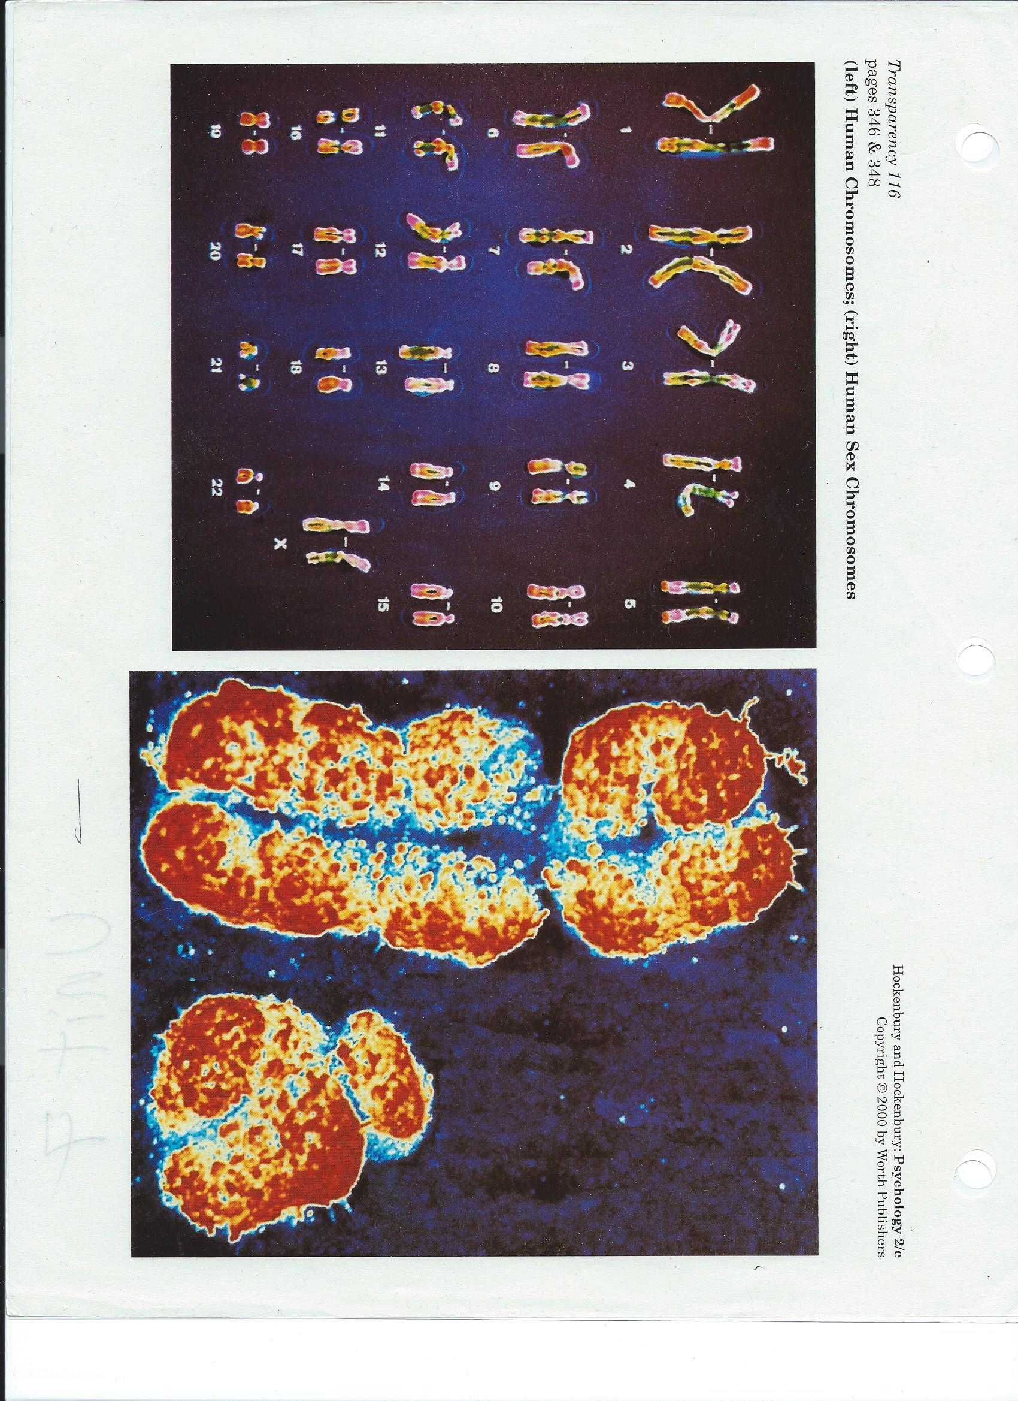
Prenatal Environmental Influences: 337-338

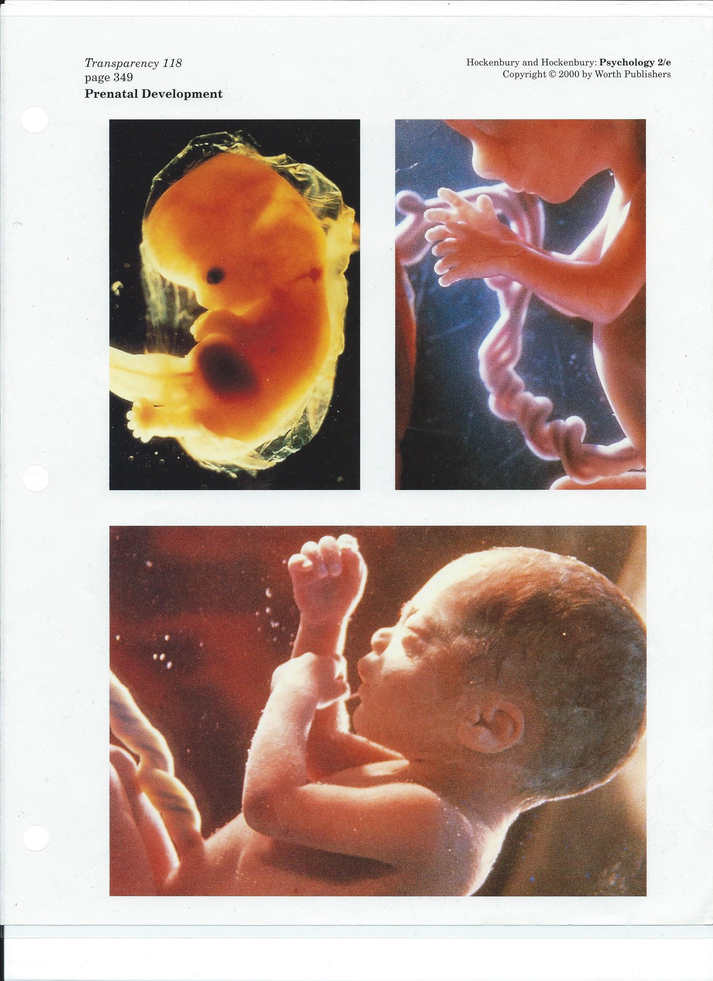
Diet
Teratogens:
x-ray
environmental hazards
pathogens
drugs
Stress
Conditioning
The Newborn: 340-344
Reflexes: startle, Babinski, grasp, rooting sucking swallowing
Senses
Temperament
Activity Level
Easy, Difficult, Slow to warm
Attachment: 344-348: Development of Social Behavior
Secure
Insecure: Avoidant, Ambivalent, Disorganized
Parent-Child Relationships: 248-250: Parenting Styles and Social
Development
Authoritarian, Permissive, Authoritative
Personal-Social Development: Erik Erikson: 350-351, 362-366
Age Stage Theory. 8 Stages
Trust-Mistrust
Autonomy-Doubt
Initiative-Guilt
Industry-Inferiority
Identity-Role Confusion
Intimacy-Isolation
Generativity-Stagnation
Integrity-Despair
Cognitive Development: 351-356
Piaget. Age Stage Theory. 4 Stages
Sensory-Motor – object permanence
Pre-operational – egocentric thinking, magical thinking, conservation of continuous properties
Concrete Operations – step by step rational problem solving
Formal Operations – abstract thinking
Information Processing Theory
Vygotsky

Moral Development: 360-362
Stages of Grief and Loss: 377-378
Denial, Anger, Bargaining, Depression, Acceptance

