Undergraduate and Graduate Students’ Mental Health During the COVID-19 Pandemic
Igor Chirikov, Krista M. Soria, Bonnie Horgos, and Daniel Jones-White
The COVID-19 pandemic has looming negative impacts on mental health of undergraduate and graduate students at research universities, according to the Student Experience in the Research University (SERU) Consortium survey of 30,725 undergraduate students and 15,346 graduate and professional students conducted in May-July 2020 at nine public research universities.
Based on PHQ-2 and GAD-2 screening tools, 35% of undergraduates and 32% of graduate and professional students screened positive for major depressive disorder, while 39% of undergraduate and graduate and professional students screened positive for generalized anxiety disorder.
Major depressive disorder and generalized anxiety disorder rates are more pronounced among low-income students; students of color; women and non-binary students; transgender students; gay or lesbian, bisexual, queer, questioning, asexual, and pansexual students; and, students who are caregivers. The prevalence of major depressive disorder and generalized anxiety disorder is higher among the undergraduate and graduate students who did not adapt well to remote instruction.
Furthermore, the pandemic has led to increases in students’ mental health disorders compared to previous years. In fact, the prevalence of major depressive disorder among graduate and professional students is two times higher in 2020 compared to 2019 and the prevalence of generalized anxiety disorder is 1.5 times higher than in 2019.

Overall Prevalence of Major Depressive Disorder and Generalized Anxiety Disorder
We used the Patient Health Questionnaire-2 (PHQ-2) two-item scale to screen for major depressive disorder symptoms (Kroenke et al., 2003) and Generalized Anxiety Disorder-2 (GAD-2) two-item scale to screen students for generalized anxiety disorder symptoms (Kroenke et al., 2007). The PHQ-2 asks two questions about the frequency of depressed mood and anhedonia over the past two weeks while the GAD-2 asks two questions about the frequency of anxiety over the past two weeks. Each question is scaled from 0 (not at all) to 3 (nearly every day). The responses to two questions in each scale are summed and, if the score for PHQ-2 >= 3 (out of 6), major depressive disorder is likely. If the score for GAD-2 is >= 3 (out of 6), generalized anxiety disorder is likely.
Based on these screening tools, 35% of undergraduate respondents and 32% of graduate and professional student respondents screened positive for major depressive disorder (Figure 1) and 39% of undergraduate, graduate, and professional students screened positive for generalized anxiety disorder (Figure 2). Among graduate and professional students, research doctoral students have higher overall prevalence of major depressive disorder (36%) and generalized anxiety disorder (43%) than students in other types of graduate and professional programs.
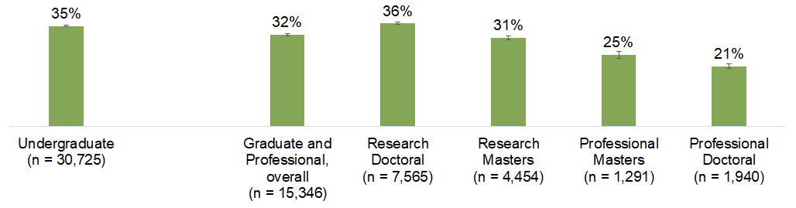
Figure 1. Overall prevalence of major depressive disorder among undergraduate and graduate and professional students (unweighted).
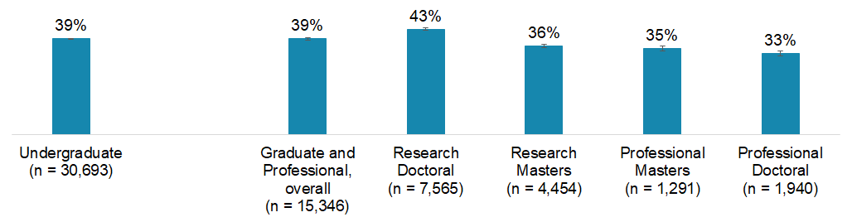
Figure 2. Overall prevalence of generalized anxiety disorder among undergraduate and graduate and professional students (unweighted).

Undergraduate Students’ Mental Health
Among undergraduate students, major depressive disorder is more prevalent among low-income or poor and working-class students; Black or African American, Latinx, and Asian students; women, transgender, and non-binary students; gay or lesbian, bisexual, queer, questioning, asexual, and pansexual students; and, caregivers of children or other adults (Figure 3).

The percentage of students who screened positive for generalized anxiety disorder is higher among low-income or poor and working-class students; Latinx and multiracial students; women, transgender, and non-binary students; gay or lesbian, bisexual, queer, questioning, asexual, and pansexual students; and caregivers of children or other adults (Figure 4).
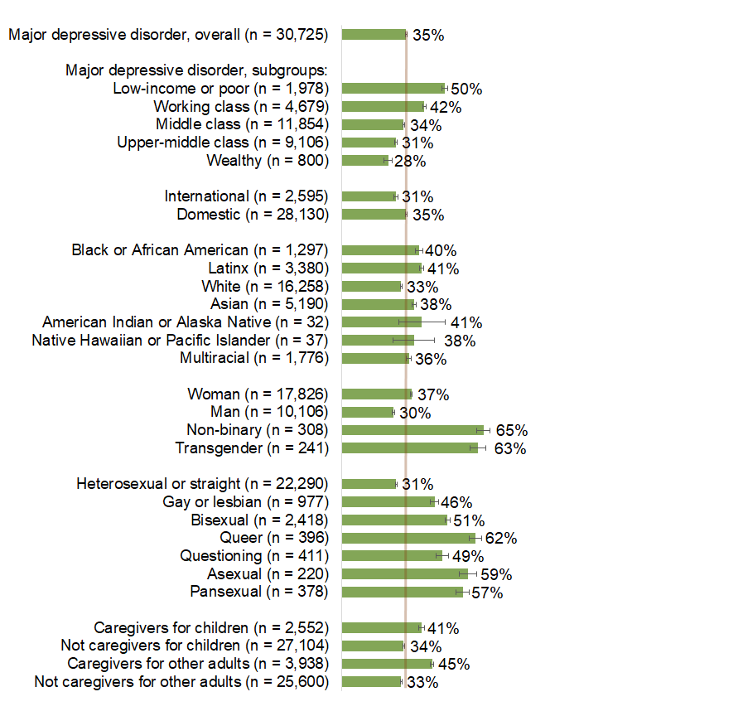 | 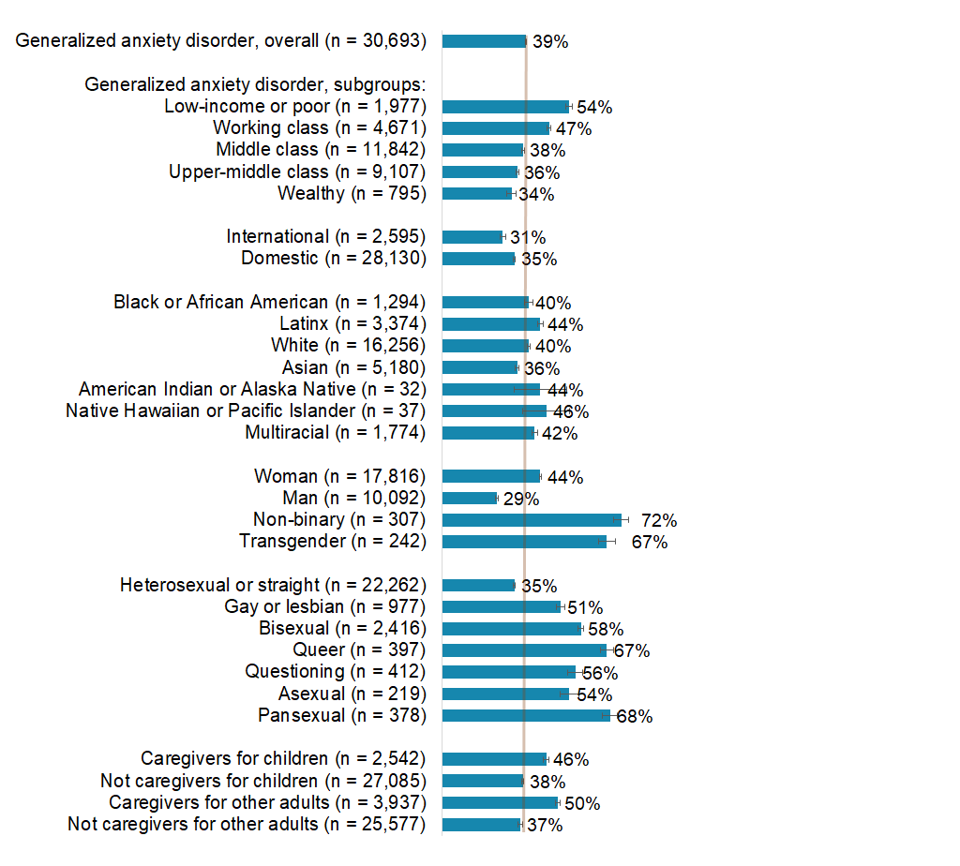
Figure 3. Percentage of undergraduate students who screened positive for major depressive disorder (unweighted). | Figure 4. Percentage of undergraduate students who screened positive for generalized anxiety disorder (unweighted).

Arts, humanities, communication, and design majors have more undergraduate students with major depressive disorder and generalized anxiety disorder than other fields of study (Figures 5 and 6).

Within arts, humanities, communication and design majors, major depressive disorder and generalized anxiety disorder is more prevalent among undergraduates studying English language and literature (45% of them screened positive for major depressive disorder and 55% of them screened positive for generalized anxiety disorder).

Social and behavioral sciences students majoring in psychology have a more pronounced level of major depressive disorder (38%) and generalized anxiety disorder (45%) than students of other majors within this field.

Although science, technology, engineering, and mathematics (STEM) students overall had lower rates of major depressive disorder and generalized anxiety disorder compared to their peers, within STEM majors, physical sciences students have a more pronounced level of major depressive disorder (40%) and generalized anxiety disorder (44%), comparable to some arts and humanities majors.
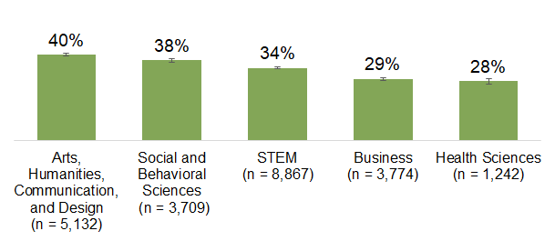
Figure 5. Undergraduate students who screened positive for major depressive disorder, by broad field of study.

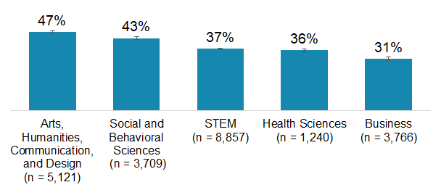
Figure 6. Undergraduate students who screened positive for generalized anxiety disorder, by broad field of study.

Graduate and Professional Students’ Mental Health
Among graduate and professional students, major depressive disorder is more prevalent among low-income or poor and working-class students; Latinx students; international students; non-binary and transgender students; gay or lesbian, bisexual, queer, questioning, asexual, and pansexual students; and, caregivers of other adults (Figure 7).
The percentage of graduate and professional students who screened positive for generalized anxiety disorder is higher among low-income or poor students; Latinx, American Indian or Alaska Native, and multiracial students; women, transgender, and non-binary students; gay or lesbian, bisexual, queer, questioning, asexual, and pansexual students; and caregivers of other adults (Figure 8).
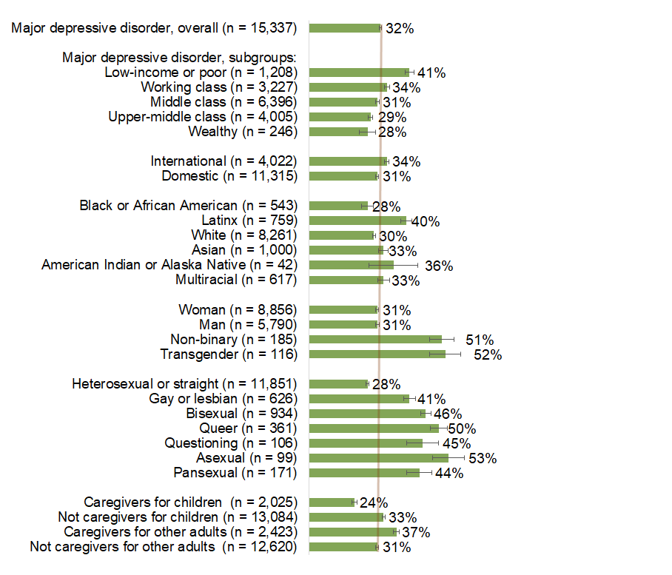 | 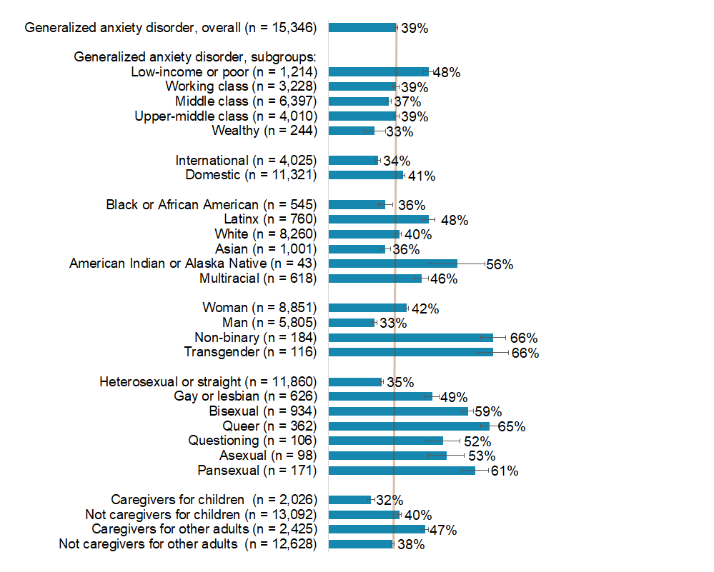
Figure 7. Percentage of graduate and professional students who screened positive for major depressive disorder (unweighted). | Figure 8. Percentage of graduate and professional students who screened positive for generalized anxiety disorder (unweighted).

Arts, humanities, communication, and design fields have more graduate and professional students with major depressive disorder or generalized anxiety disorder than other fields of study (Figures 9 and 10). Similar to undergraduates, within arts, humanities, communication, and design fields of study, major depressive disorder and generalized anxiety disorder is more prevalent among graduate and professional students studying English language and literature (51% of those students screened positive for major depressive disorder and 63% of screened positive for generalized anxiety disorder).

Social and behavioral sciences students studying anthropology have a more pronounced level of major depressive disorder (51%) than students in other fields. Students in sociology and anthropology have a more pronounced level of generalized anxiety disorder (58% and 57%, respectively) than students in other fields.

Although STEM graduate and professional students had lower rates of major depressive disorder and generalized anxiety disorder compared to their peers, within STEM degrees, physical sciences students have more pronounced levels of major depressive disorder (39%) and biology and biomedical sciences students have more pronounced levels of generalized anxiety disorder (44%).
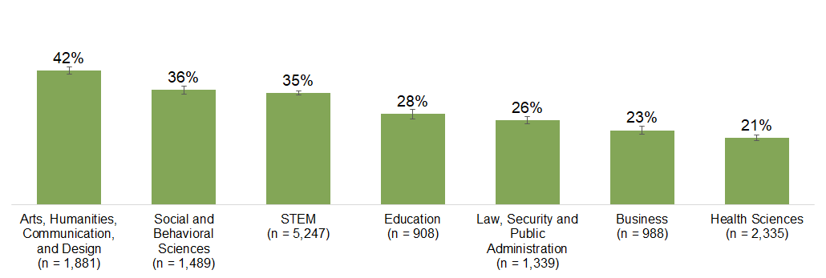
Figure 9. Graduate and professional students who screened positive for major depressive disorder, by broad field of study.
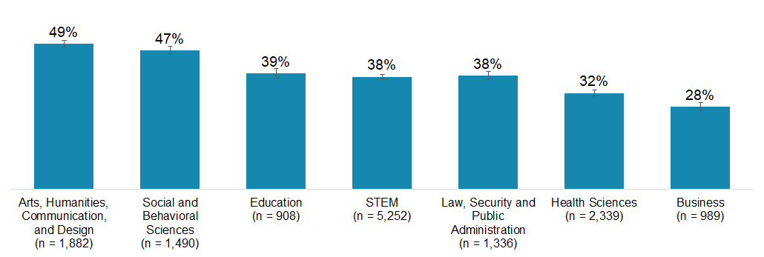
Figure 10. Graduate and professional students who screened positive for generalized anxiety disorder, by broad field of study.

Graduate and Professional Students’ Mental Health Before and During the Pandemic
In Spring 2019, the SERU Consortium surveyed graduate and professional students at public research universities using the same PHQ-2 and GAD-2 scales. The prevalence of major depressive disorder among graduate and professional students is two times higher in 2020 compared to 2019. The prevalence of generalized anxiety disorder is 1.5 times higher in 2020 compared to 2019 (Figure 11). The increase in the prevalence of major depressive disorder and generalized anxiety disorder in 2020 is consistent across graduate student populations by gender, degree level, and social class.
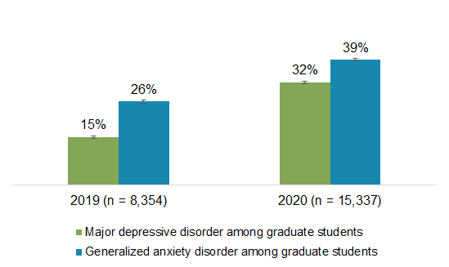
Figure 11. Prevalence of major depressive disorder and generalized anxiety disorder among graduate and professional students in 2019 and 2020.

Mental Health and Remote Instruction
The prevalence of major depressive disorder and generalized anxiety disorder is higher among undergraduate and graduate students who did not adapt well to remote instruction (Figures 12 and 13). More than half of undergraduate and graduate students who reported they did not adapt well to remote instruction screened positive for major depressive disorder and generalized anxiety disorder.
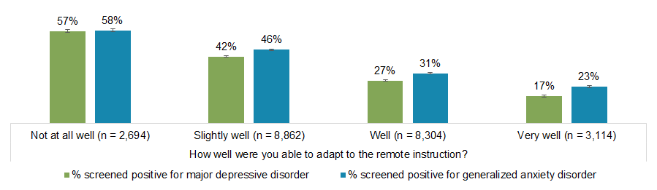
Figure 12. Prevalence of major depressive disorder and generalized anxiety disorder among undergraduate students, by the degree of adaptation to remote instruction.

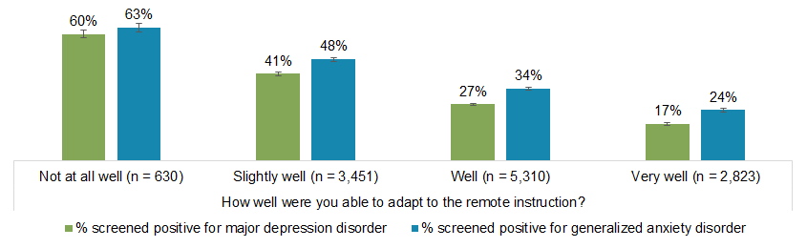
Figure 13. Prevalence of major depressive disorder and generalized anxiety disorder among graduate and professional students, by the degree of adaptation to remote instruction.

Conclusions & Recommendations
The results of our study suggest that undergraduate, graduate, and professional students are experiencing significant mental health challenges during the COVID-19 pandemic. Specifically, it appears as though between one-third to two-fifths of students screened positive for major depressive disorder and generalized anxiety disorder, respectively. Below, we have outlined our recommendations across major thematic areas.

Allocate more resources, reduce barriers, and increase communications.
Colleges and universities should plan to allocate more resources for a potential increase in students’ requests for mental health services, including counseling or therapeutic services, this upcoming fall 2020 semester. While most colleges and universities transitioned to offering telemental health services, including telecounseling and teletherapy, they may need to expand current offerings to provide more appointment times, increase their counseling staff, or network with third-party vendors to expand available mental health services to students. Furthermore, colleges and universities should work proactively to publicize these resources through sending widespread communications to students, encouraging staff and faculty to disseminate information, or creating moderated peer support groups. Given that many students may not be as physically present on campuses in fall 2020, it is especially important to send those communications via a variety of platforms (e.g., course management systems, newsletters, in virtual class lectures, emails, text messages, or physical mail).
Colleges and universities should actively work to eliminate some of the other barriers to students’ ability to seek mental health resources; for instance, students who need but do not use mental health services report barriers related to the availability, location, or timing of appointments (Stebleton et al., 2014). Furthermore, students also report that they do not understand the types of services that are offered, they have never heard of the services, or they do not have time to access or use services (Stebleton et al., 2014). In addition to increased promotion of services, we recommend that administrators work to reduce barriers by offering appointments at various times of the day and increasing counseling staff to reduce waitlists.

Expand telecounseling programs and focus on preventative services.
Colleges and universities experienced some initial barriers to offering telecounseling services to students who had relocated to a different state during the pandemic; however, many state governments enacted emergency executive orders to allow service providers to work across state lines. We encourage colleges and universities to continue to expand telecounseling services, remove barriers to facilitate effective counseling relationships with students, offer alternative methods of delivery (e.g., group counseling), and focus on offering more preventative services (e.g., stress reduction workshops).

Engage faculty and academic advising staff.
Faculty and academic advisors should also plan for potential impacts upon students’ engagement in classes, achievement, and overall well-being—and recognize that drops in students’ engagement or achievement could be connected to students’ mental health. We encourage faculty to exercise compassion for students and to direct students to support services on campus that can assist with providing students with accommodations (i.e., especially if their mental health disorder is a disability that qualifies for accommodations).
Given their critical front-line roles with students, faculty are well-positioned to proactively embed mental health resources in their classes; for instance, faculty can embed mental health modules in their learning management software programs, provide contact information for mental health resources in their in syllabi, and frequently email students to share information about how to access mental health services on campus. Such actions can help to de-stigmatize mental health disorders and increase students’ comfort when reaching out for help.
Furthermore, faculty and academic advisors will be critically important in addressing the needs of students within academic majors and fields of study where we observed higher rates of major depressive disorder and generalized anxiety disorder. Our survey results suggest that students majoring in arts, humanities, communication, and design majors, along with those in social and behavioral sciences students, may have higher rates of mental health disorders compared to their peers. We recommend that faculty and advising staff in the academic programs that have the highest prevalence of major depressive disorder and generalized anxiety disorder receive additional training on how to identify mental health risks and refer students to appropriate resources on campus.
Our results also suggest that challenges in adaptation to remote instruction are associated with students’ mental health. When planning and implementing instruction remotely in fall 2020 and beyond, colleges and universities should consider providing additional mental health support to students who struggle with remote instruction. We encourage colleges and universities to complement institutional strategies to improve students’ mental health with academic program-based interventions and services.

Work alongside students.
We encourage administrators to work hand in hand with students as they develop new strategies to improve students’ mental health and reduce their stress. Many colleges and universities have student organizations focused on mental health advocacy and awareness and we encourage administrators to work alongside students to develop interventions, create proactive programs, and expand existing services.
Overall, the increase in the numbers of undergraduate, graduate, and professional students who screen positive for major depressive disorder and generalized anxiety disorder are alarming and may present significant challenges to colleges and universities as students return to campus—whether physically or virtually—in the upcoming semester. We recommend proactive approaches at multiple levels to address the levels of stress, generalized anxiety disorder, and major depressive disorder that students are experiencing.

About the SERU COVID-19 Survey
The Student Experience in the Research University (SERU) Consortium administered a special survey on the impact of COVID-19 on student experience at nine public research universities. The SERU COVID-19 Survey assesses five areas to better understand undergraduates, graduates, and professional students’ experiences during the global pandemic: 1) students’ transition to remote instruction, 2) the financial impact of COVID-19 for students, 3) students’ health and wellbeing during the pandemic, 4) students’ belonging and engagement, and 5) students’ future plans. You can access the full survey instrument here.

Sample
The survey was a census survey administered from May 18 to July 20, 2020 to undergraduate, graduate, and professional students at large, public research universities. The report uses data from 30,725 undergraduate students and 15,346 graduate and professional students. The response rate was 14-41% at the respective institutions. You can review more about the full sample here.

About the SERU Consortium
The Student Experience in the Research University (SERU) Consortium is an academic and policy research collaboration based at Center for Studies in Higher Education at the University of California – Berkeley (CSHE) working in partnership with the University of Minnesota and partner institutions. More information about the SERU survey is available at https://cshe.berkeley.edu/seru

Contact Information
Igor Chirikov, PhD, SERU Consortium Director and Senior Researcher, Center for Studies in Higher Education, UC Berkeley. chirikov@berkeley.edu

Krista M. Soria, PhD, Assistant Director for Research and Strategic Partnerships, SERU Consortium, and Director for Student Affairs Assessment, University of Minnesota. ksoria@umn.edu

Suggested APA Citation
Chirikov, I., Soria, K. M., Horgos, B., & Jones-White, D. (2020). Undergraduate and graduate students’ mental health during the COVID-19 pandemic. SERU Consortium, University of California - Berkeley and University of Minnesota. https://cshe.berkeley.edu/seru-covid-survey-reports

References
Kroenke, K., Spitzer, R. L., & Williams, J. B. (2003). The Patient Health Questionnaire-2: Validity of a two-item depression screener. Medical Care, 41, 1284-1292.
Kroenke, K., Spitzer, R. L., Williams, J. B., Monahan, P. O., & Löwe, B. (2007). Anxiety disorders in primary care: Prevalence, impairment, comorbidity, and detection. Annals of Internal Medicine, 146, 317-325.
Stebleton, M. J., Soria, K. M., & Huesman, R. L. (2014). First-generation students’ sense of belonging, mental health, and use of counseling services at public research universities. Journal of College Counseling, 17(1), 6-20.

