Unit 7 Expanded Outline
Consciousness and Its Altered States
PERCEPTION 116-126
Gestalt Laws
Figure-ground
Closure
Proximity
Similarity

Linear Perspective

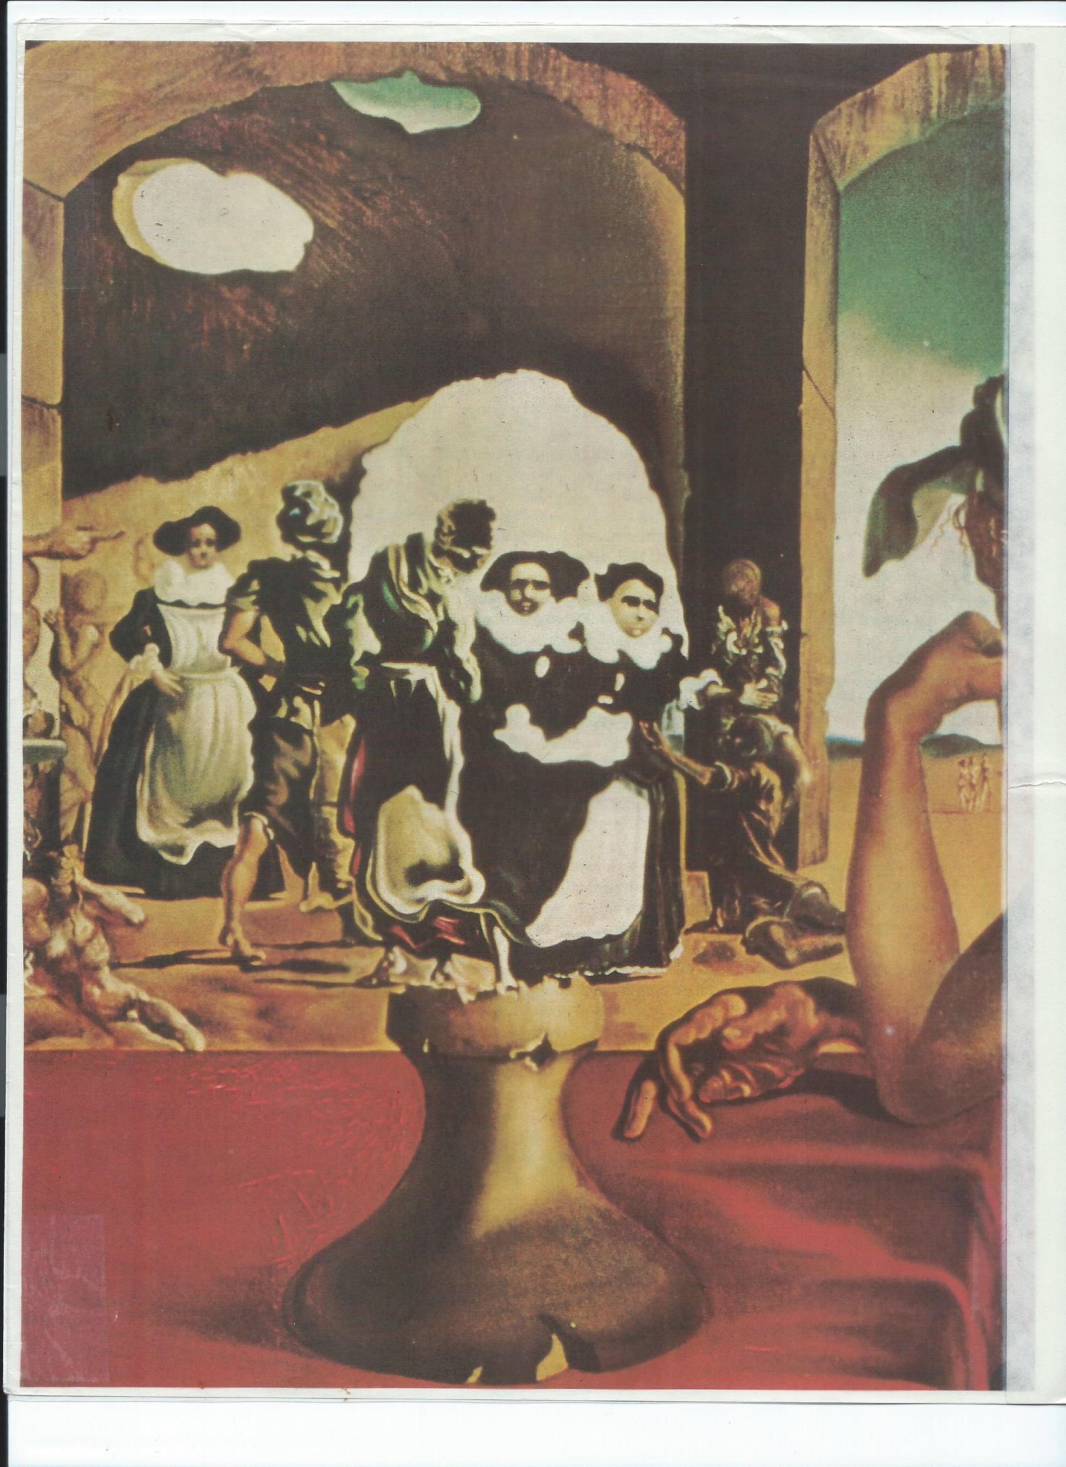
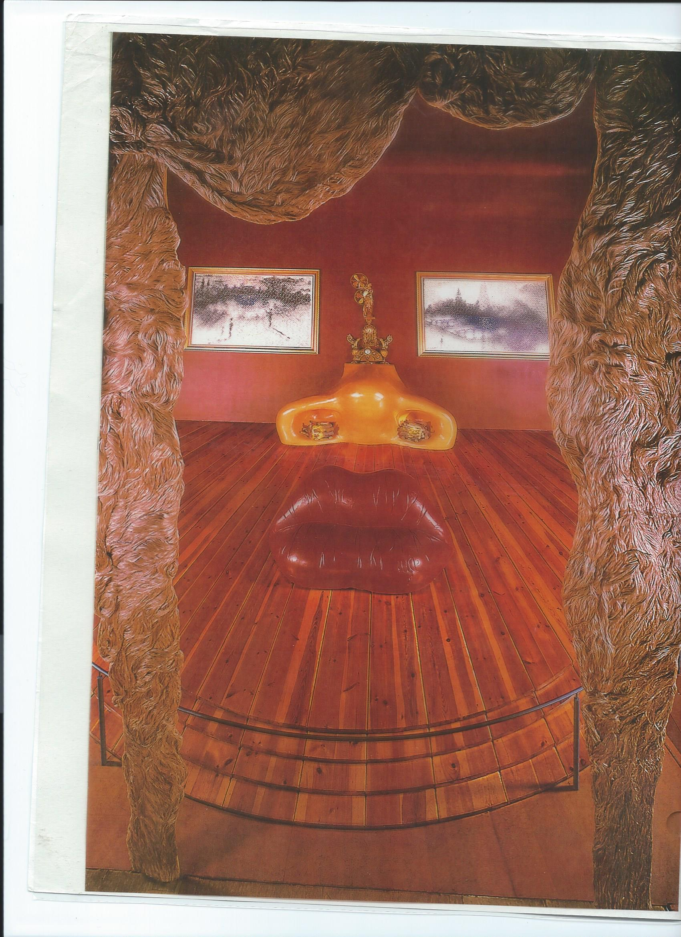
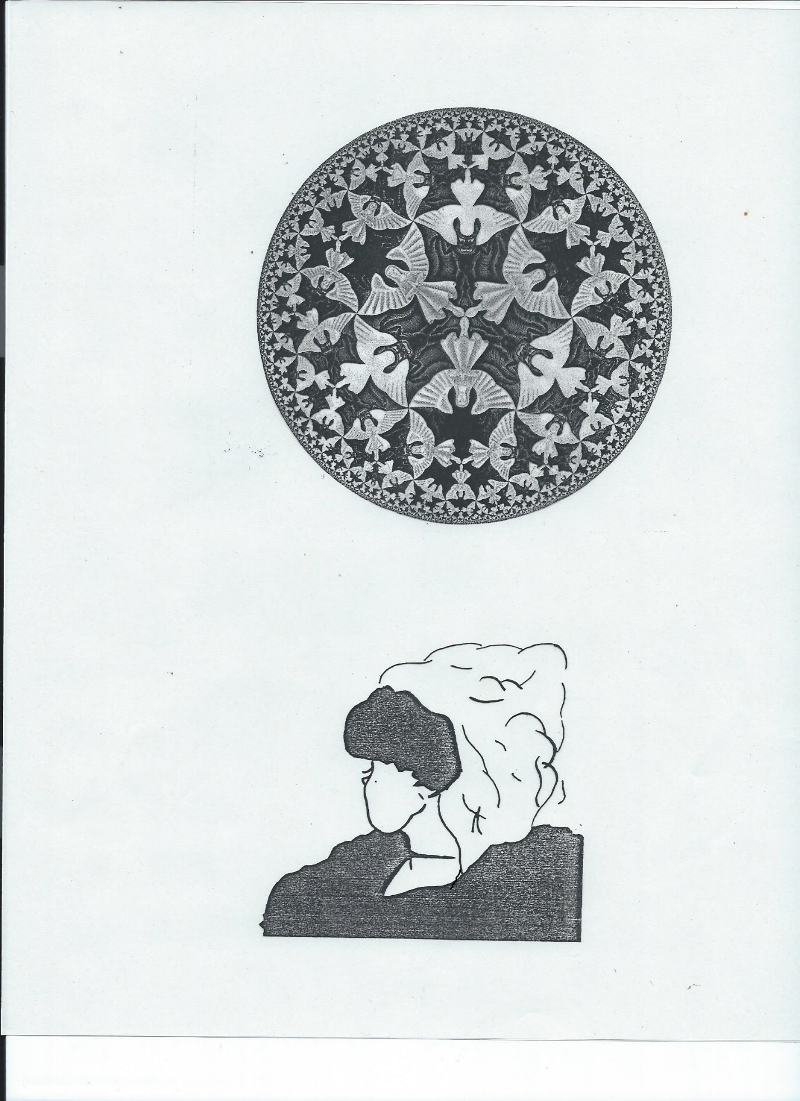
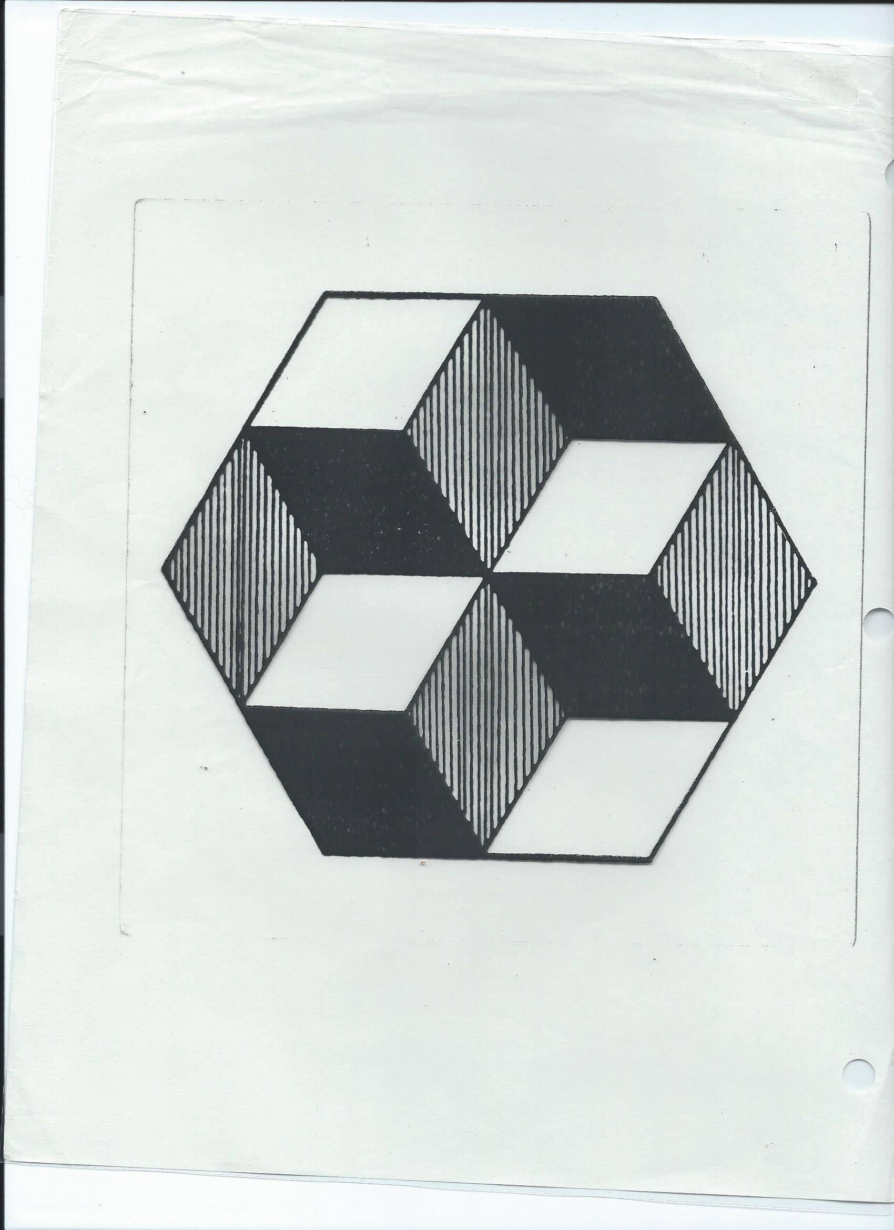

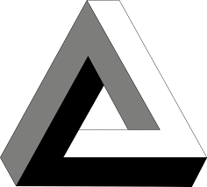

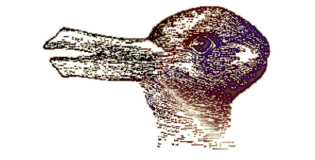

PERSPECTIVES:
Psychoanalysis. Unconscious
Behaviorism. Reinforcement, punishment, vicarious learning
Humanism. Hierarchy of needs
Cognitive Psychology. What we are thinking about
Biology. Sensory modalities
Sociocultural Psychology (e.g. prejudice)
CONSCIOUSNESS definition. What thoughts, feelings. Sensations, perceptions we are aware of at any given moment
CHARACTERISTICS OF ALTERED STATES OF CONSCIOUSNESS
Thinking, emotion, time sense, perception and sensation, control, suggestibility, ineffability
PSYCHOACTIVE DRUGS 152-163
Mode of operation. Synapse
Factors affecting the effects of a drug. 1st time, dose, expectations, social context, culture
Addiction
Physiological/physical
- Tolerance/habituation
- Physical withdrawal symptoms
Psychological
- Belief cannot function without it
- Drug comes first
- Withdrawal: anxiety, depression, aggression
A slippery slope. SEE p. 162
Students, why use, why addiction?
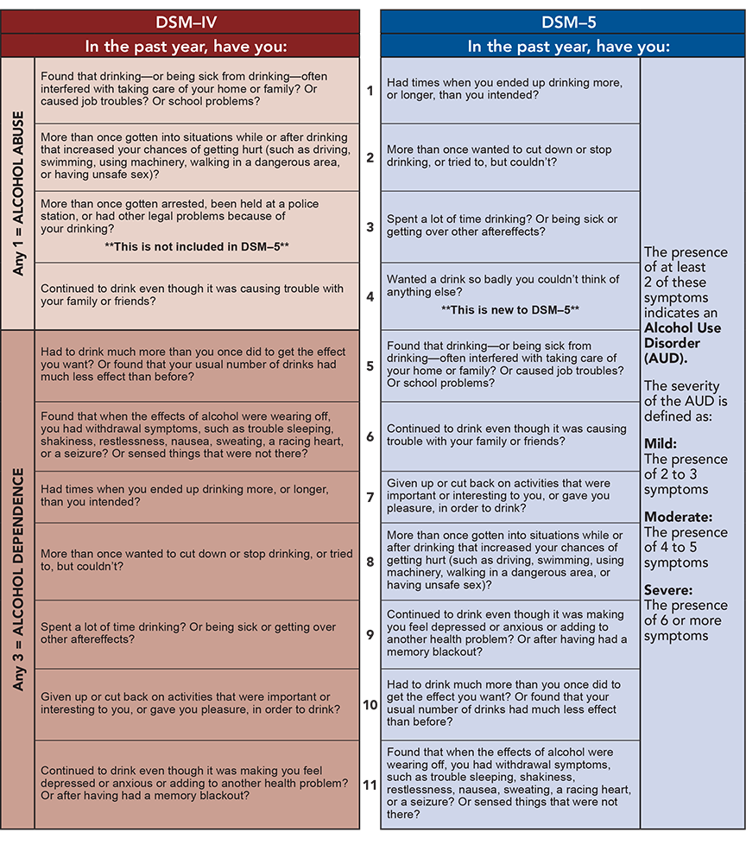

RISK FACTORS FOR ADDICTION
- Genetics; Epigenetics
Behavioral Genetics
Twin Studies, Family Studies , Adoption Studies
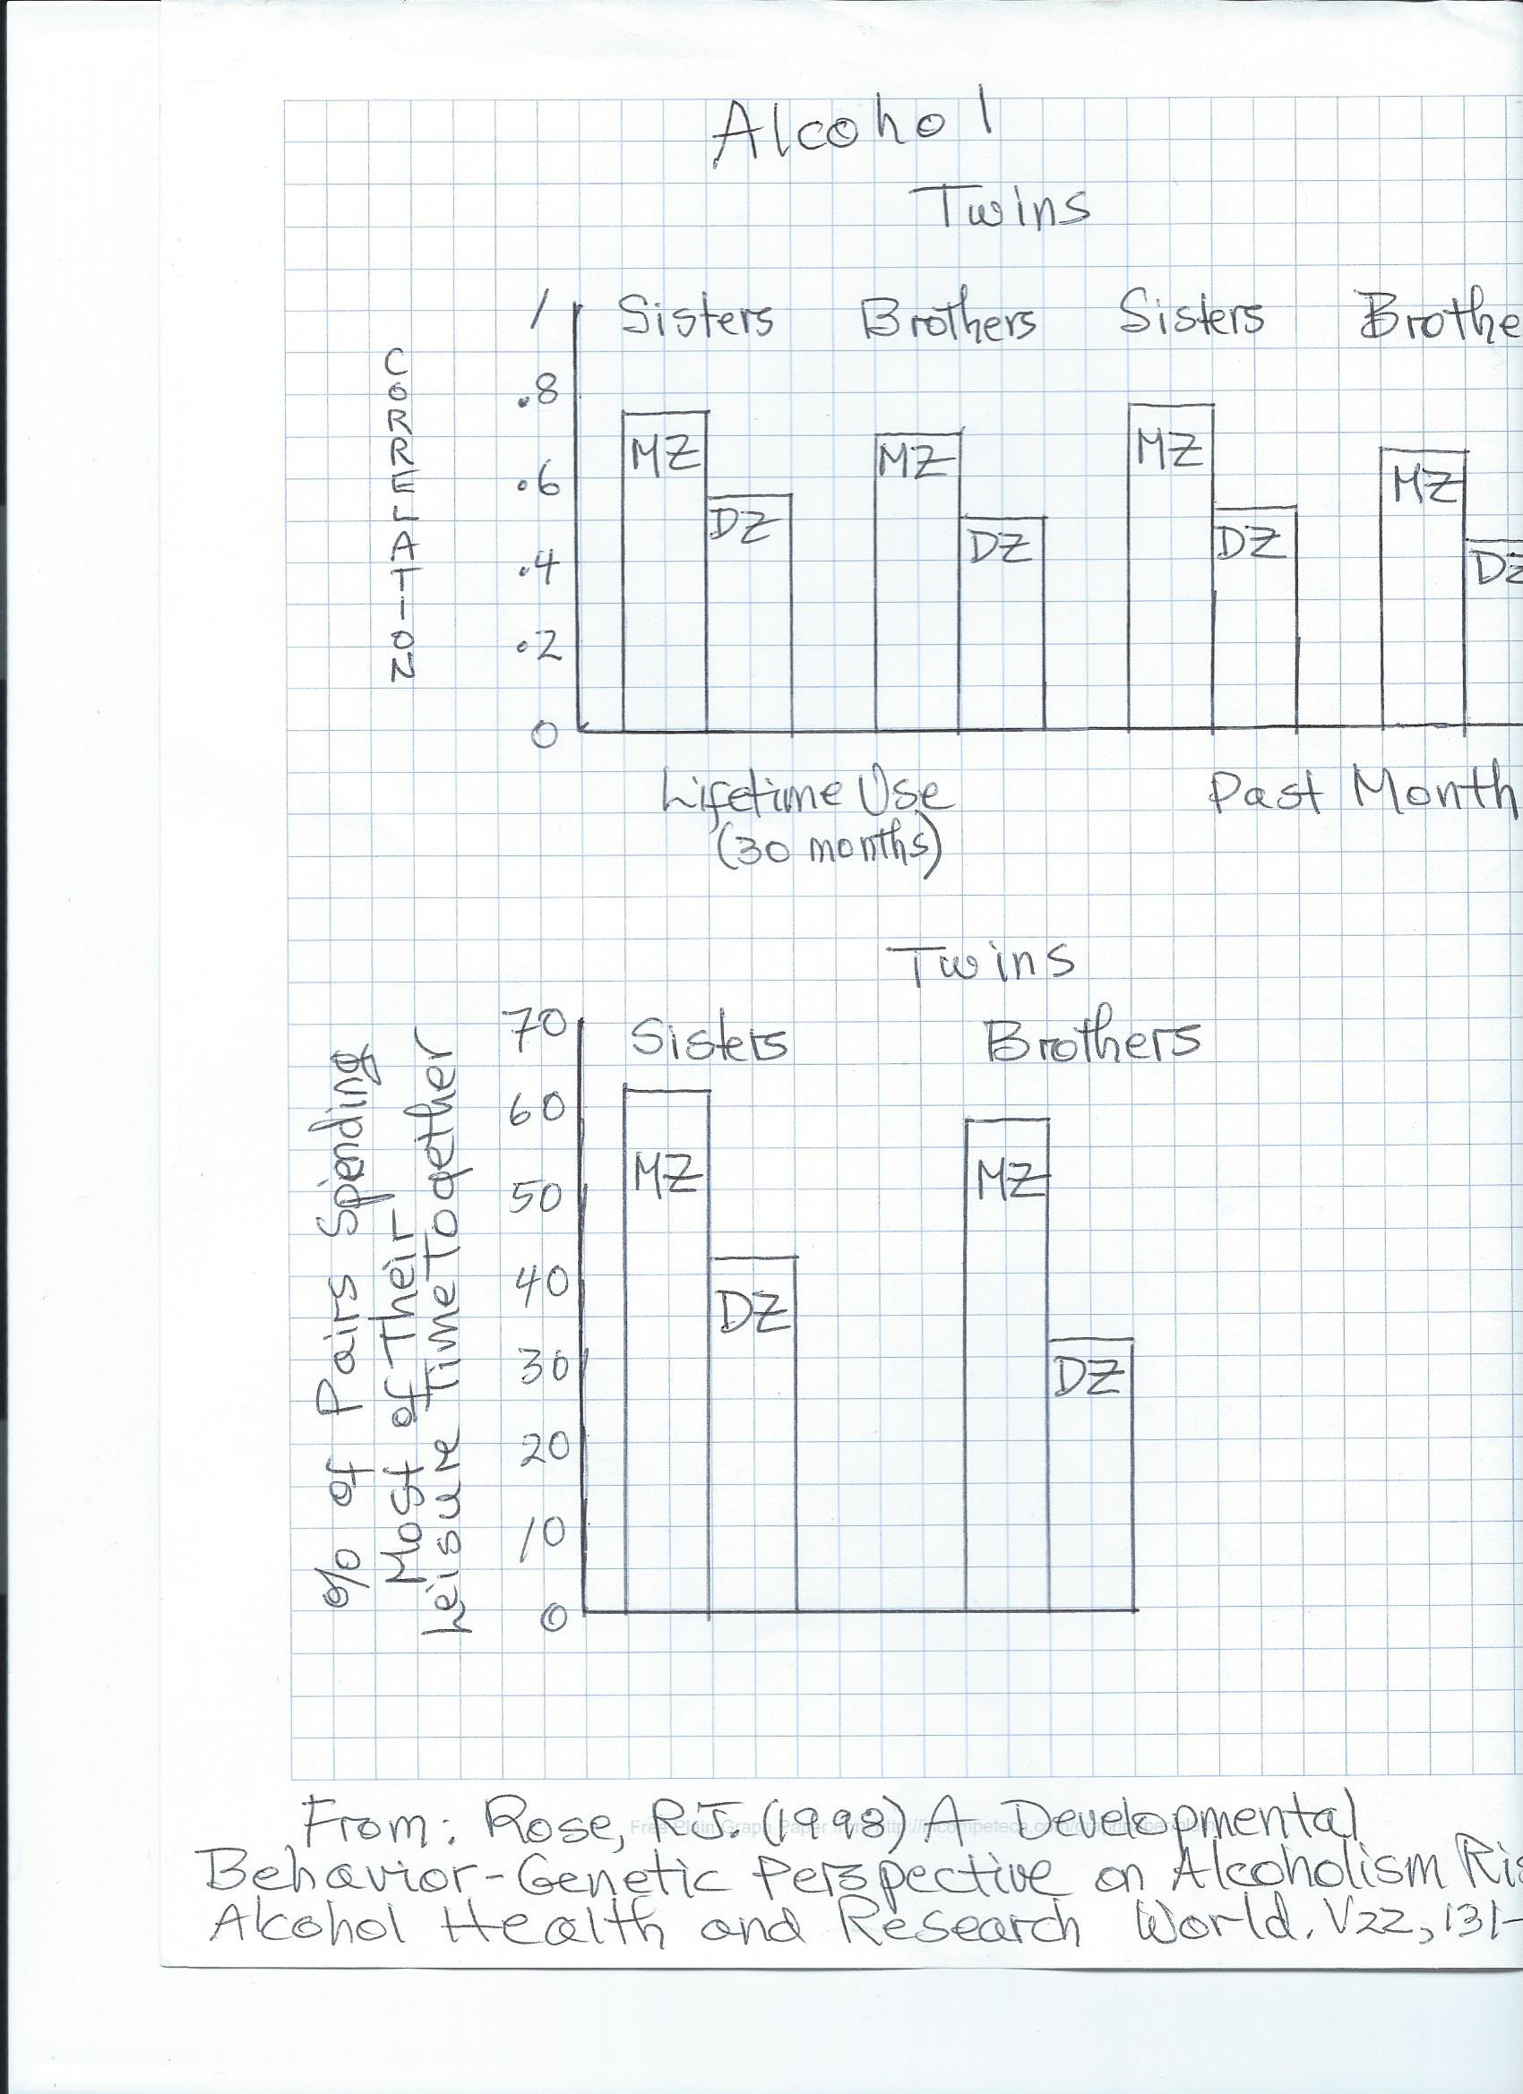

- Personality
Addictive personality
Freud?
- Behaviorism
- Family
Abuse
Drug Use: Vicarious Reinforcment
- Overcoming social inhibitions
- Stress: inner and outer
- Culture
- Drug itself
- Drug availability
- Pre-dispositional Model
Treatment
- 12 steps
- Psychotherapy
- Controlled Use
- Hypnosis
- Reinforcement for Sobriety
- Pharmacology
Drugs and ASC Characteristics???
DREAMS AND SLEEP 133-145
- Prophetic
- Psychological Health and Hidden Meaning
Freud: Manifest and Latent Content
Displacement
Projection
Distortion
Condensation
Symbols: personal and universal
Jung
Perls
- Activation Synthesis
- Dreams for Survival. P.140
- Fun
REM SLEEP. 20% SLEEP TIME. Pages 134, 135.
Stages of sleep and EEG. Figure 2, p. 134

REM and health. 1. Deprivation and signs of psychological disorder
2.Rebound effect
Neurology and Dreams. Prefrontal Cortex less active; Limbic System more active
ASC Characteristics and Dreams???

HYPNOSIS. P. 147
https://youtu.be/aEl2FZE6z98
Zimbardo
Induction
Susceptibility. P. 147
Neo-Dissociation Theory
Uses:
- Pain control
- Change bad habits
- Psychological disorders
- Criminal investigation
- Improve athletic and exam performance. Note: extra credit opportunity

ASC characteristics???

Students: Healthy ways of altering consciousness?

