Psychology 1A. Unit 2 Expanded Outline. S 21

Unit 2. Behaviorism, Learning and Memory: 18-19, Chapter 5, 398-399, 429-430.
Introduction: 18-19: The Behavioral Perspective
Learning: a change in behavior resulting from experience

Classical Conditioning: 169-175 Reflex Behavior

Reflex: an inborn, automatic observable, measurable response (UR) to an observable, measurable stimulus (US) for example, the response, salivation (UR), to the stimulus, food in the mouth (US).

Unconditioned Stimulus (US)
Unconditioned Response (UR)
Conditioned Stimulus (CS)
Conditioned Response (CR)

The reflex is the US and the UR

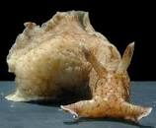
Aplysia and other gastropod molluscs exhibit complex behaviors that can be modified by associative learning. We have now produced classical conditioning in the defensive siphon and gill withdrawal reflex of Aplysia. We used as a conditioned stimulus (CS) a light tactile stimulus to the siphon, which produces weak siphon and gill withdrawal. As the unconditioned stimulus (US), we used a strong electric shock to the tail, which produces a massive withdrawal reflex. Specific temporal pairing of the CS and US endowed the CS with the ability of triggering enhanced withdrawal of both the siphon and the gill. Random or unpaired presentations of the CS and US, as well as presentations of the CS or US alone, produced either no enhancement or significantly less enhancement than paired presentations of the CS and US. The conditioning is acquired rapidly (within 15 trials) and is retained for several days.

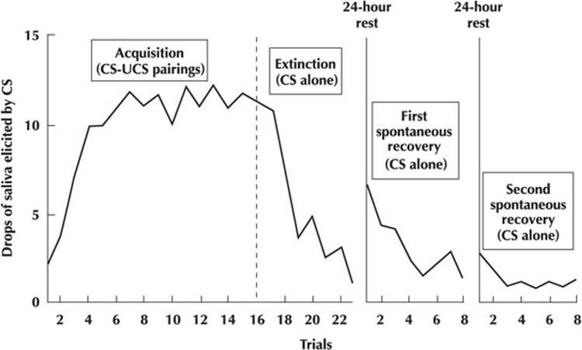

Principles of Classical Conditioning
Preparedness: 175
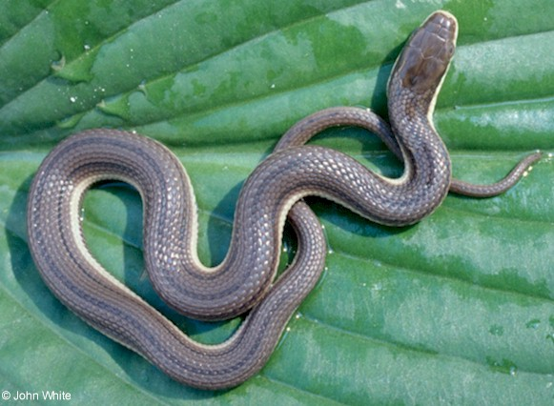

Timing: 171

Extinction and Spontaneous Recovery in Classical Conditioning:
173-174

Generalization and Discrimination in Classical Conditioning: 174
Higher Order Conditioning
A neutral stimulus is paired with an already established CS and comes to elicit the CR.

Experimental Neurosis:
Presenting a stimulus midway between a + CS and a – CS, or a stimulus that has been associated both with a + UCS and with a – UCS.

Operant Conditioning: 177-186

(Doc: Unit 2 op cond Skinner, et al)
Can Pigeons Read https://youtu.be/I_ctJqjlrHA

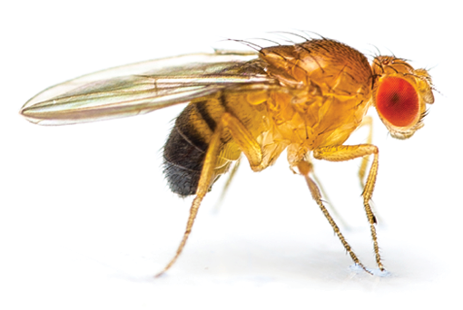Fruit Fly
Reinforcement and Punishment: 178-180
Positive and Negative Reinforcements. 180
Positive Reinforcement: anything whose presence following a response leads to an increase in that response. A student gets an A on a paper and works even harder on the next paper.
Negative Reinforcement: Anything whose removal following a response leads to an increase in that response. While I am reading your papers, I hear the sound of a motor that annoys me. I look around and find it’s a fan. I turn the fan off. The next time I hear that sound, I immediately turn the fan off. (True story)
Primary and Secondary Reinforcements.
Primary Reinforcement: Positive: e.g.,Food, Water, Optimal temperature,
Smile
Negative: e.g, pain, loud sound
Secondary Reinforcement: Anything associated with a primary reinforcement and/or an already established secondary reinforcement. E.g., money
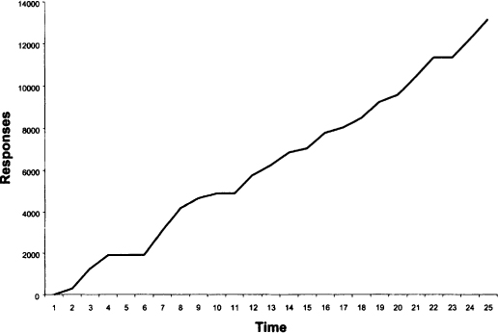
Punishment: 180

Principles of Operant Conditioning
Timing
Extinction and Spontaneous Recovery

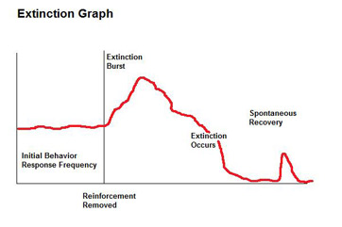
Paradox of avoidance conditioning: the more frequently an avoidance response is made, the more likely is a failure to make the avoidance response
Generalization and Discrimination: 184

Schedules of Reinforcement: 182-184 Fixed ratio, Fixed Interval, Variable Interval, Variable Ratio

Shaping: 186
Superstitious Conditioning: accidental conditioning
https://youtu.be/2ZgeGke5ckU
Pros and Cons of Punishment: 181-182
Pro: stops undesirable behavior immediately
Cons: 1. Person and place of punishment become aversive (secondary negative reinforcers)
2. Punished individual learns force as problem solution
3. Punished behavior goes underground
4. lowered self esteem

Learned Helplessness: 429-430 Inescapable punishment leads to learned helplessness

Personality: 398-399

Finale: Operant conditioning in a Sea Turtle
Some may find it strange to see video of a turtle in the marine mammal blog, but the marine mammal staff has the opportunity to train a sea turtle as well. The principals of operant conditioning and positive reinforcement can work with any animal, as long as you learn what it is that they find rewarding. Myrtle, a green sea turtle, finds fish and Brussels sprouts absolutely fabulous! Myrtle is approximately 75 years old and has been at the aquarium almost as long as we've been open. We began by teaching Myrtle to "target" or touch a white PVC pipe, by putting it in front of her and rewarding her for touching it. From there, she learned to discriminate between a white pipe, a black pipe and a black and white striped pipe. She has been stellar at this, always choosing her white pipe when presented with a choice. Now we have moved on to sending her to search for her target around the tank. Her signal to start searching is a sound made by popping a smaller pole in the water and pulling it out.

Sea Turtles: https://youtu.be/HG4c8d2C88A

Operant conditioning exercises:
What is the liklihood of recurrence of the behavior in dark print (for example, volunteers)? What principle is involved – positive reinforcement, negative reinforcement or punishment?
- 1) A student volunteers to answer a tough question in class; the teacher comments favorably on the student’s answer.
2) If the students now volunteers to answer tough questions in other classes, what principle of operant conditioning is involved? If, in the other classes, the teachers do not comment favorably, what is the likely recurrence of volunteering in those classes? What principle? The student now volunteers only in the original class. What principle?
- 1) A wife brings home flowers to her husband because of the special dinner he cooked for her.
2) The husband cooks dinner the very next night. What is the likelihood of her bringing flowers? What principle is involved?
- 1) A child is sent to his room with no supper after presenting a bad report card.
2)The child brings home good report cards the next two occasions, then a not so good report card and the 4th report card is not good. What principle? How might good report cards be maintained?
- 1)Dad and tot are at the supermarket. When the child screams for candy, Dad pops a sucker in her mouth to quiet her.
2)Every time the child screams at the supermarket, Dad pops a sucker in her mouth. What principle?
- 1)Child spills milk on the supper table and Mom spanks him.
2)Several occasions of drinking milk and no spills. Then the child spills the milk again. What principle? How might Mom maintain no spilling behavior?
- 1)A student has a terrible headache after intense exam preparation. He takes two aspirin and the headache goes away.
2)The student takes an aspirin before intense test preparation. What behavior is this? After doing this several times, the student forgets to take the aspirin. What principle is involved?.
g. 1) A child screams for French fries at a fast food restaurant. The parents surrender and give her a big batch of fries; the child stops screaming.
2)Her parents give her French fries on random occasions driving by the fast food restaurant. What schedule of reinforcement is this? If they stop giving her French fries when they pass the restaurant, will extinction of screaming occur more quickly or less quickly after this schedule than if she had been given French fries every time they passed the restaurant?
h. 1) A terrorist applies an electric current to the feet of a spy so the spy will confess. The spies tell the terrorist everything.
2) The terrorist continues to use electric current to the feet of spies. What principle?

Social Learning Theory: 194-196:
Observational Learning: learning by imitating
Vicarious learning:
vicarious reinforcement: imitating the behavior of someone seen
reinforced for that behavior.
vicarious punishment: NOT imitating behavior seen punished for
that behavior.
Characteristics of a model which increase likelihood of imitation:
Warm and nurturing
Holds the power to reinforce and punish
Attractive, appealing
Familiar
Characteristics of imitator
Emotional arousal

Aggression
Gender role
Culture and Learning: 197-198: Exploring Diversity
Memory: xxxvi-xlix, Chapter 6

Textbook Learning and Memory:
Levels of Processing: 219-220
Reinforcement
Rehearsal: 209
Active Responding
State Dependence:
Sensory Modality
Chunking. 208
Overlearning
Distribution of Practice:
Primacy and Recency: 230: Proactive and Retroactive Interference
Flashbulb Memories: 221-222
Mnemonics: 209
Memory Reconstruction: 222-224: Constructive Processes in Memory
Forgetting: 229-230: Why We Forget

The Seven Sins of Memory
By Daniel Schacter, published on May 1, 2001 - last reviewed on March 1, 2011
Transience, Absentmindedness/Distraction, Blocking, Bias, Persistence, Misattribution, Suggestibility (Eye Witness Testimony)
Improving memory: xxxvi-xlix, 233-234

.

