Unit 1 Outline

Please Note: Unless otherwise cited, the numbers below refer to pages in your textbook.
Unit 1. Freud and Psychoanalysis: 18, 224-225, 385-393.

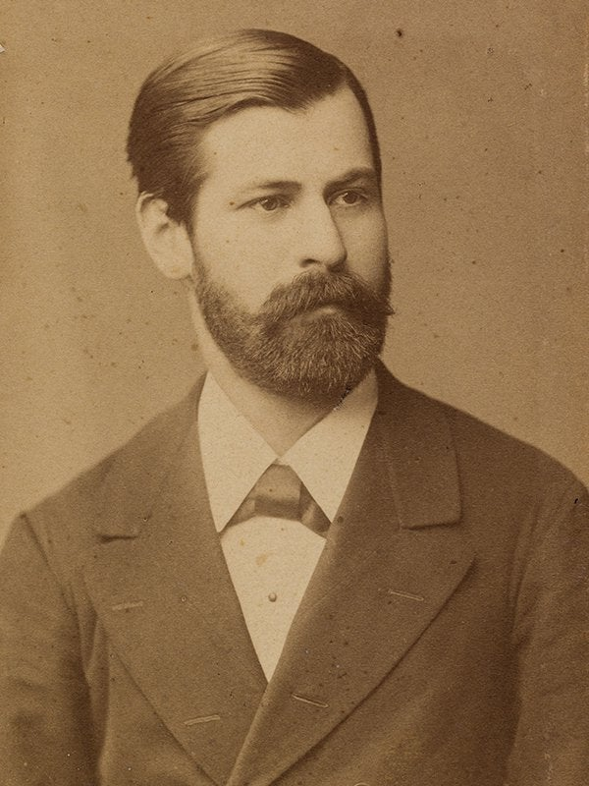

Introduction: 18: The Psychodynamic Perspective

From a Freudian Psychoanalystic view, what is most important in determining our behavior, thoughts, feelings, sensations perceptions – what makes us do what we do??? THE UNCONSCIOUS AND CHILDHOOD EXPERIENCE. The idea that our behavior and mental processes are largely determined by forces within us, of which are unaware is very much a part of psychology today. As you will see in Unit 11, Developmental Psychology, the idea that what happens to a person between birth and 2 years affects them throughout life is central, and controversial, in Child Psychology.
Determinism: The belief that every behavior, thought, feeling and sensation has a cause(s) to which we can point. When we know the cause(s), we can then predict and control that behavior and/or mental process(es)
Instincts:
Instinct – Inborn patterns of behavior.
Example: In the Springtime, the male White Crowned Sparrow sings from various perches in his territory. If there is a female WCS in the area she will flutter her wings. When the male WCS sees the wing fluttering he will sing his song more frequently which leads to more wing fluttering in the female WCS. This is part of their instinctual mating behavior.
Eros – Pleasure seeking instinct
Thanatos – Destructive instinct
Libido – Pleasure seeking energy
Age-Stage Theory of Personality Development: 387-388:
Personality. Definition p.38

(See Canvas, Module 2, personality sample mmpi)

Oral Stage: birth to about 1 ½ years
libido focused on mouth: babies spend a great deal of their waking life putting things in their mouths – fingers, toes, food, anything that comes within their grasp, literally.
Everyday life issue: feeding and weaning. As well as assuring just the right amount (a theoretical average) of oral gratification (pleasure) between birth and about 11/2, the child must be weaned from this stage, weaned from breast/bottle to a cup. . When the child is weaned, most of the Libido is focused on the next stage, but some Libido remains at the Oral Stage; we continue to seek pleasure orally, but it is no longer our main source of pleasure. If the baby receives too little or too much oral gratification, Fixation will result.
FIXATION:
More libido than average is left behind at the oral stage. The fixated individual continues to seek pleasure primarily orally. Examples: chewing gum always, non stop smoking, eating disorders.
- Logic Alert: Even if it was absolutely true (which we cannot say at this point) that fixation results in the eating disorders , we cannot conclude, when we see someone with an eating disorder, that the person is fixated at the Oral Stage. There could be many other reasons/causes for Eating Disorders.

Too little gratification: aggressive personality. Aggressive in every aspect of life, including play – for example, loves football, playing football, watching football on TV. Football is sometimes called “pro-social aggression”.

Too much gratification: dependent personality. Needs someone else to help make even the smallest decisions in life, e.g., what to wear ro a party (a zoom party, of course).
Every day life issue – feeding and weaning
Anal Stage: about 1 ½ to about 3 years
“. . . the major source of pleasure changes from the mouth to the anal region, and children obtain considerable pleasure from both retention and expulsion of feces.” 388 In other words, libido is focused on the anus, AND ALSO ON PARENTAL APPROVAL.
Too little gratification/harsh toilet training: compulsive personality. This person will become anxious in the face of a “mess” in any area of life – a messy desk, a messy relationship, my documents file. To be without anxiety, this person requires neatness and orderliness in every aspect of life. We may all be suffering from chaos in our lives right now; the compulsive personality will suffer the most.
Too much gratification: expulsive personality. This person is constantly giving – love, money, information, things, help.
Combination of too little and too much gratification: retentive
personality. Waits until they can get maximum approval for giving – love, money, things, information, help
Every day life issue – toilet training
Phallic Stage: about 3 to about 6 years
Libido focused on genitals
Boys:
Desire for mother
Hostility toward father
Boy fears retaliation from Father, in the form of castration
Castration anxiety
Identification with father: boy imitates the Father and later internalizes the attitudes of Father. This is the beginning of traditional Gender Role Development. An issue on the forefront of Psychology today is the very meaning of “gender”, one of the major topics in Gender Psychology, Psychology 40, here at SRJC.
Girls:
Sense of inferiority
Hostility toward mother
This is one of the most questionable and controversial aspects of Freudian Theory – that women feel inferior and experience penis envy, that our anatomy (men and women) determines our gender role and our place in society!
Desire for father
Incest taboo
Identification with mother

Every day life issue – gender role

Fixation at phallic stage: incomplete identification with parent of same gender MAY be followed by failure to develop a conscience – sociopathy???
Latent: about 6 to about 12 years
Libido is inactive.
Further identification with parent of the same gender; further development of
Gender role.
Genital: from about 12 to 20’s
Libido re-aroused.
Oedipus and Electra re-aroused:
Effect on relationship with caregivers

Structure of the Psyche: 386-387

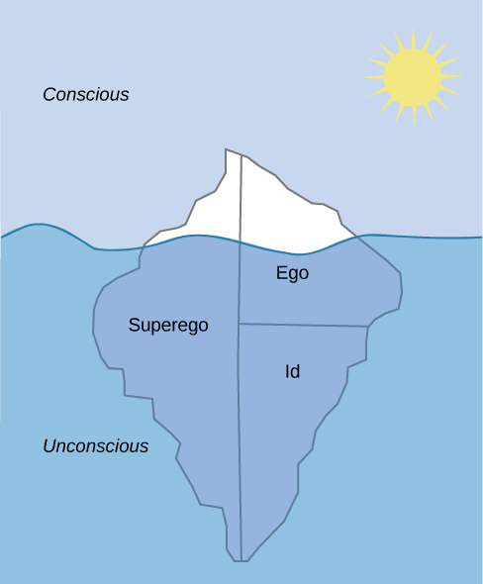
Conscious - awareness
Preconscious – material of which you are not conscious, but which is easily accessed
Unconscious – all feelings, memories, desires of which we are unaware; defense mechanisms. More difficult to access
Id – Eros and Thanatos; in unconscious
Super-go – conscience, source of guilt; in conscious, preconscious and unconscious
Ego – the thinker, problem solver, mediator between id and super-ego; mostly in the conscious part of the Psyche, but also in the pre-conscious and the Defense Mechanisms are in the unconscious.

Defense Mechanisms: 388-390
Repression, Regression, Displacement, Rationalization, Denial. Projection, Sublimation, Reaction Formation, Intellectualization, Psychological Numbing/Emotional Insulation, Identification
Role of Ego

Recovered Memories: 224-225: Repressed and False Memories

Jung; Adler; Horney: 391-393: The Neo-Freudian Psychoanalysts

Jung

(Unit 1. Carl Gustave Jung)

Collective Unconscious: Inherited from our ancestors; transmitted to all humans from generation to generation.

Archetypes: symbols, ideas, concepts in the collective unconscious, fro example, anima and animus.

Personality Traits. Extroversion-Introversion

Horney

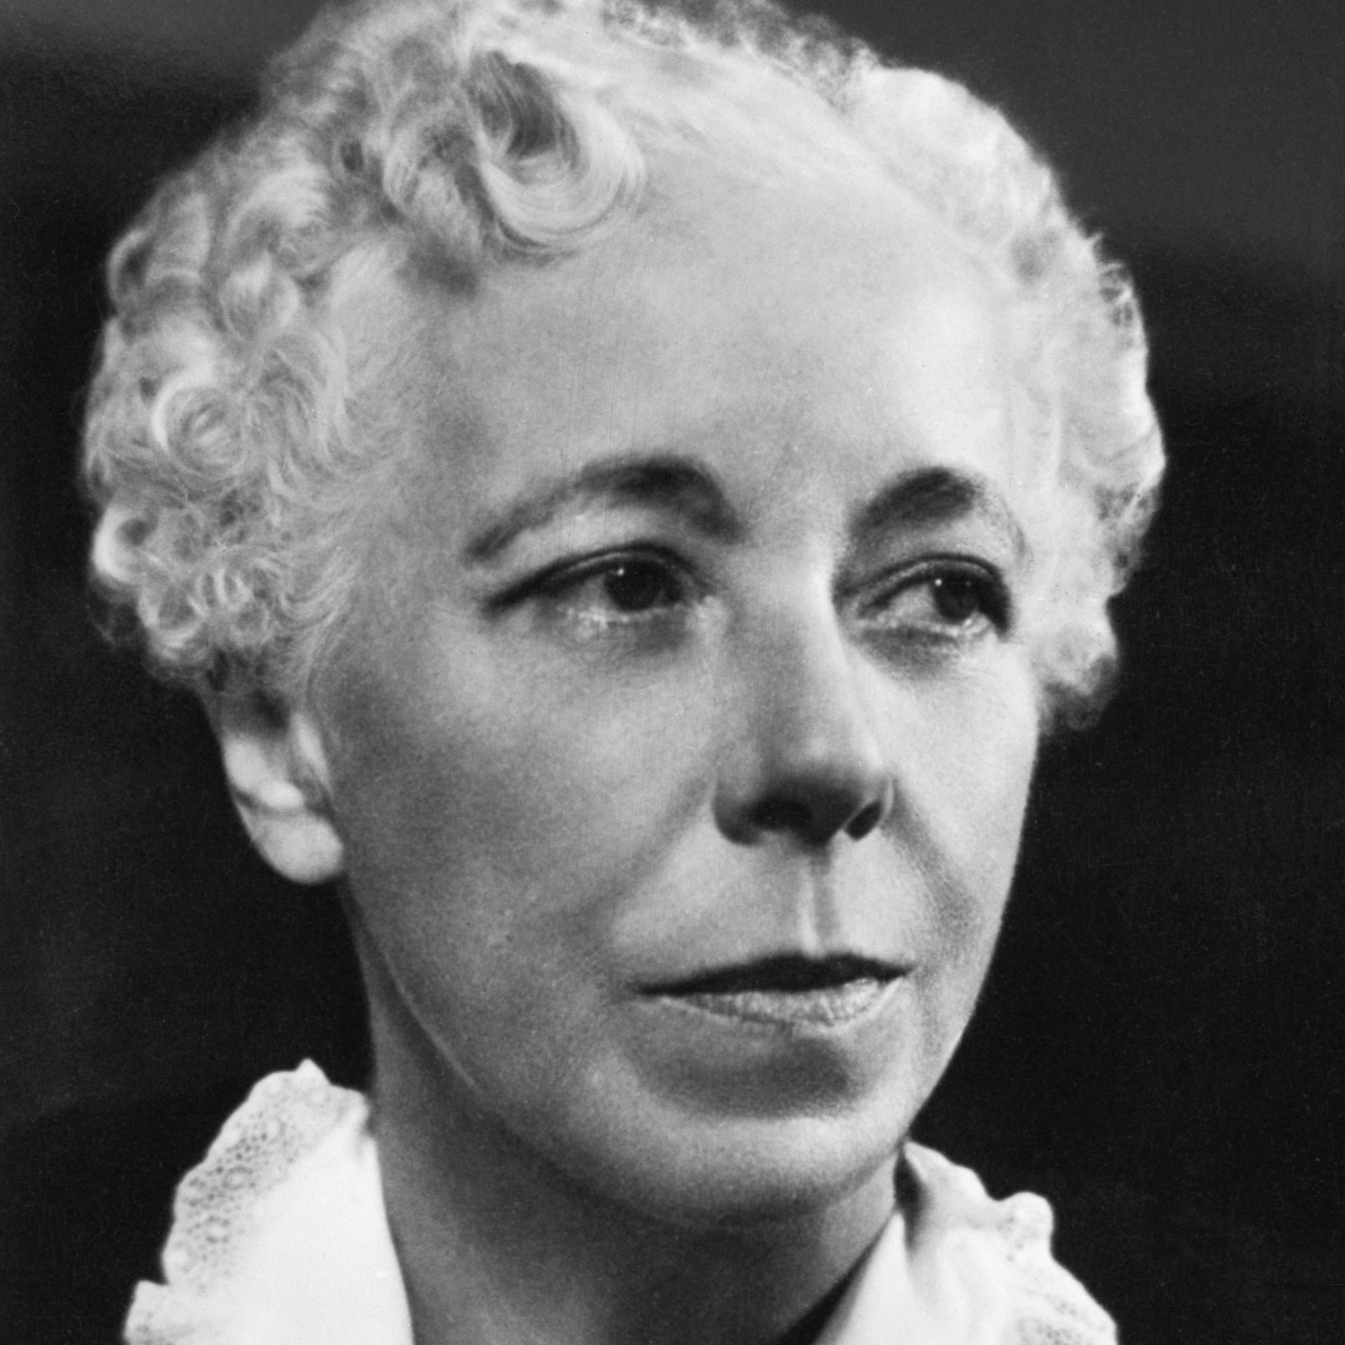

Personality and society vs. anatomy is destiny.
Womb envy vs. penis envy
Insecurity: driving force in personality development. Neurotic Trends – Compliant, Aggressive, Detached personalities

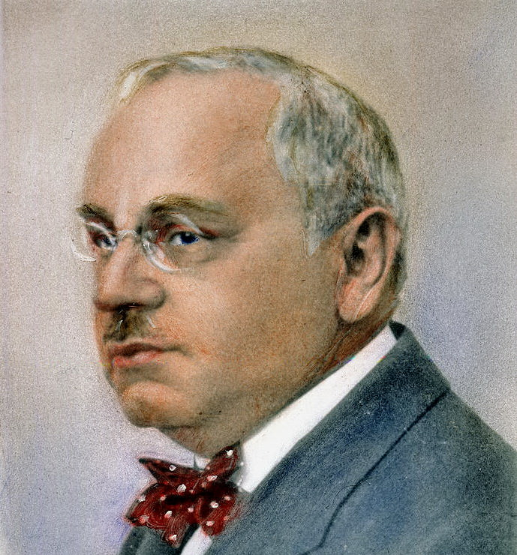

Inferiority: driving force in personality development
Compensation: development of strength in one area, for example scholarship, to make up for real or imagined weakness, for example, social skills.

Evaluating Psychodynamic Theories: 390-391: Evaluating Freud’s Legacy

Freud’s theory is extremely rich in ideas, for example, the unconscious and the role of childhood esperience, but limited in generalizability.
(Unit 1. Freud on Freud- utube)

