Unit 1 Outline

Please Note: Unless otherwise cited, the numbers below refer to pages in your textbook.
Unit 1. Freud and Psychoanalysis: 18, 224-225, 385-393.

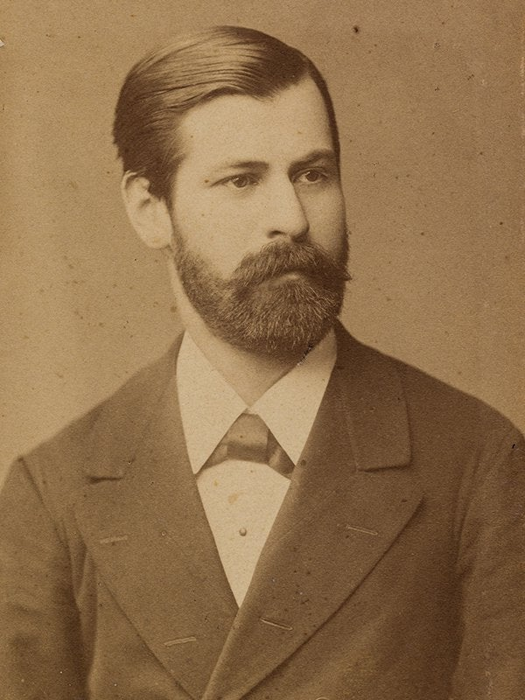
Introduction: 18: The Psychodynamic Perspective
Determinism
Instincts:
Eros
Thanatos
Libido

Age-Stage Theory of Personality Development: 387-388:
Personality

Oral Stage.
Fixation: Dependent Personality
Aggressive Personality

Anal Stage.
Fixation: Compulsive Personality
Expulsive Personality
Retentive Personality

Phallic Stage.
Gender Role

Latent Stage.

Genital Stage.

Structure of the Psyche: 386-387

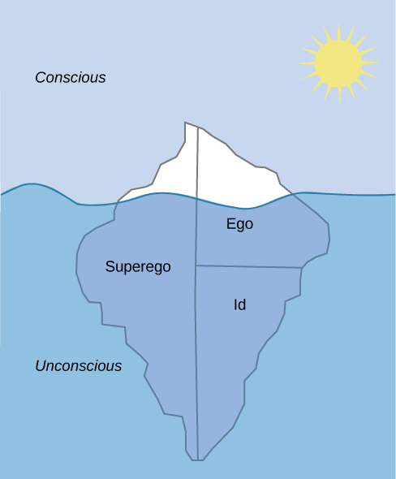
Conscious
Preconscious
Unconscious
Id
Super-go
Ego

Defense Mechanisms: 388-390
Repression, Regression, Displacement, Rationalization, Denial. Projection, Sublimation, Reaction Formation, Intellectualization, Psychological Numbing/Emotional Insulation, Identification
Role of Ego

Recovered Memories: 224-225: Repressed and False Memories

Jung; Adler; Horney: 391-393: The Neo-Freudian Psychoanalysts

Carl Gustave Jung)

Collective Unconscious

Archetypes

Personality Traits

KarenHorney

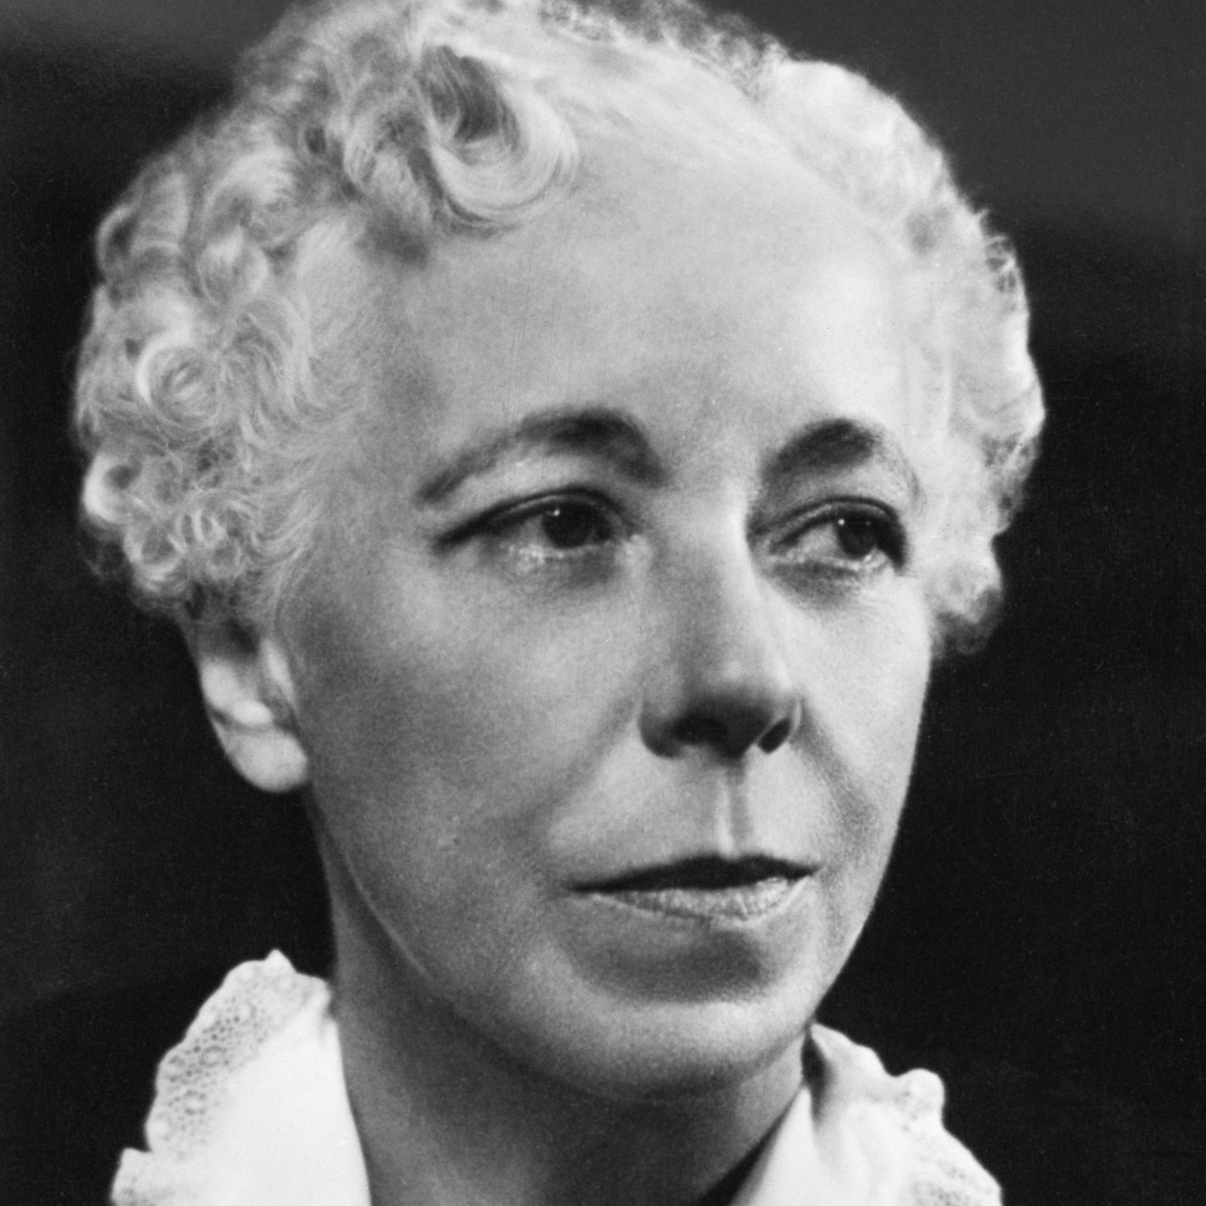

Personality and society
Insecurity: Neurotic Trends – Compliant, Aggressive, Detached

Alfred Adler

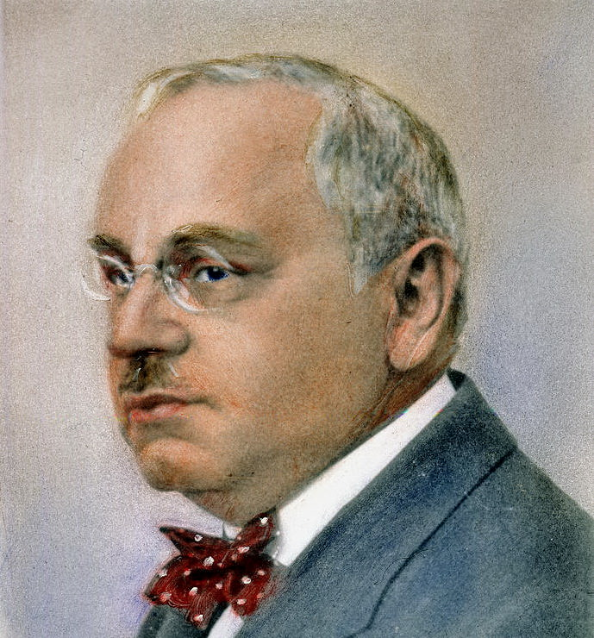
Inferiority
Compensation

Evaluating Psychodynamic Theories: 390-391: Evaluating Freud’s Legacy

