Section 4.2
A quantitative random variable x is a random variable if the value that x takes on in a given experiment or observations is a chance or random outcome.
A discrete random variable can take on only a finite number of values or a countable number of values. A continuous random variable can take on any of the countless numbers of values in a line interval.
- The expected value is often referred to as the ”long-term” average or mean. This means that over the long term of doing an experiment over and over, you would expect this average.
- The mean of a random variable X is µ.
- If we do an experiment many times and record the value of X each time, the average is likely to get closer and closer to µ as we keep repeating the experiment. This is known as another version of the Law of Large Numbers.
Example Which of the following are continuous variables, and which are discrete?
- x = the number of siblings a person has.

- x = a person’s height.

- x = the amount of time it takes a statistics student to finish an exam.

- x = the number of units a student takes in a quarter.

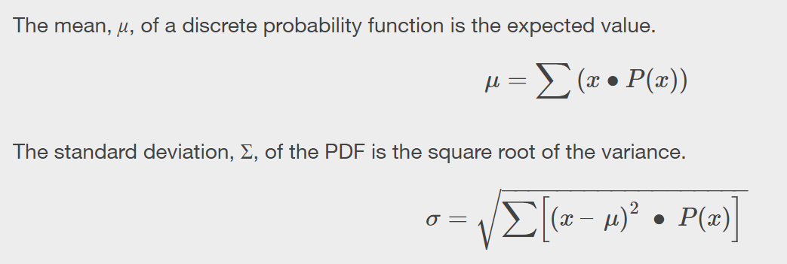
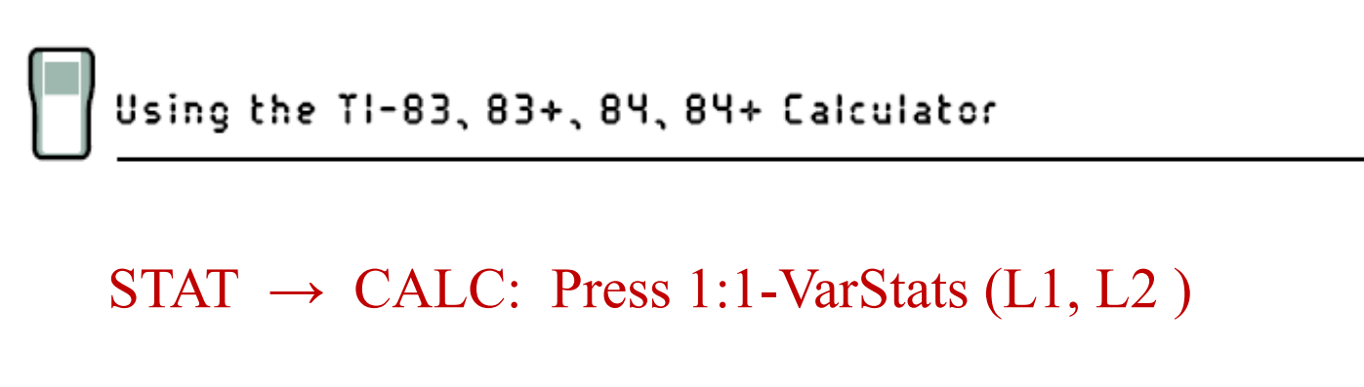
Example Consider the following probability distribution of a discrete random variable, x. Complete the table so that it is a valid probability distribution.

x | 0 | 1 | 2 | 3
P (x) | 0.4 | 0.2 | 0.1

Example A dust mite allergen level that exceeds 2 micrograms per gram (µ_{g}/g) of dust has been associated with the development of allergies. Consider a random sample of 4 homes. Let x = number of homes with a dust mite allergen level that exceeds 2 µ_{g}/g. The probability distribution for x is given below.

x | 0 | 1 | 2 | 3 | 4
P (x) | 0.09 | 0.30 | 0.37 | 0.20 | 0.04

- Find the probability that at least three of the homes have a dust mite level that exceeds 2 µ_{g}/g.

- Find the probability that fewer that two of the homes have a dust mite level that exceeds 2 µ_{g}/g.

- Compute and interpret µ.
Example Consider the game consisting of rolling a pair of fair dice and recording the sum. It will cost you $1.00 to play this game. If the sum is at least 10, then you will win $3.00. If the sum is 2, you will win $2.00. Otherwise, you will lose the game.
Probability Distribution: Winnings
x | $3.00 | $2.00 | $0.00
P (x)

- What are your expected earnings per dollar wagered? Show your work and interpret your result.

- Are your expected earnings equal to the cost to play?

- If you played this game one million times, how much money would you expect to earn/lose?
Example Suppose that Nigel wants to take out a $100, 000 term insurance policy. Nigel is 60 years old and according to the actuarial tables, there is a 1.191% chance Nigel will die this year. If the insurance company wants to make $700 profit per policy of this type, how much should the insurance company charge Nigel? Show your work and give your answer in the form of a sentence.
- Determine the probability distribution table. There are only two possibilities, you either pay out on the policy this year or you don’t:

x | $100, 000.00 | $0.00
P (x)

- Now calculate the expected pay out per person for this year.

- If they want to make $700 per person (on average) how much should they charge?
Example To raise money, the ASFC is holding a raffle. The prize is a Walt Disney World vacation for two valued at $3000. The ASFC sold 1382 raffle tickets at $5 each.

- Antonia bought 10 tickets. What is the probability that she will win?

- What are Antonia’s expected earnings?

- Are Antonia’s expected earnings equal to the cost to play?
Example Revisited Consider the game consisting of rolling a pair of fair dice and recording the sum. It will cost you $1.00 to play this game. If the sum is at least 10, then you will win $3.00. If the sum is 2, you will win $2.00. Otherwise, you will lose the game.
Probability Distribution: Winnings
x | $3.00 | $2.00 | $0.00
P (x) | 1 | 1 | 29
 | 6 | 36 | 36

Find the Standard deviation of this Probability Distribution Table.

