Unit 11 Expanded Outline F 20

Developmental Psychology: Chapter 9
Developmental Psychology is the study of Behavior and Mental Processes from conception through the life span.

Nature-Nurture. Throughout Unit 11, starting with the Newborn, we will discuss the role of Nature and the role of Nurture with regard to every stage of development. See pages 329 through 331.
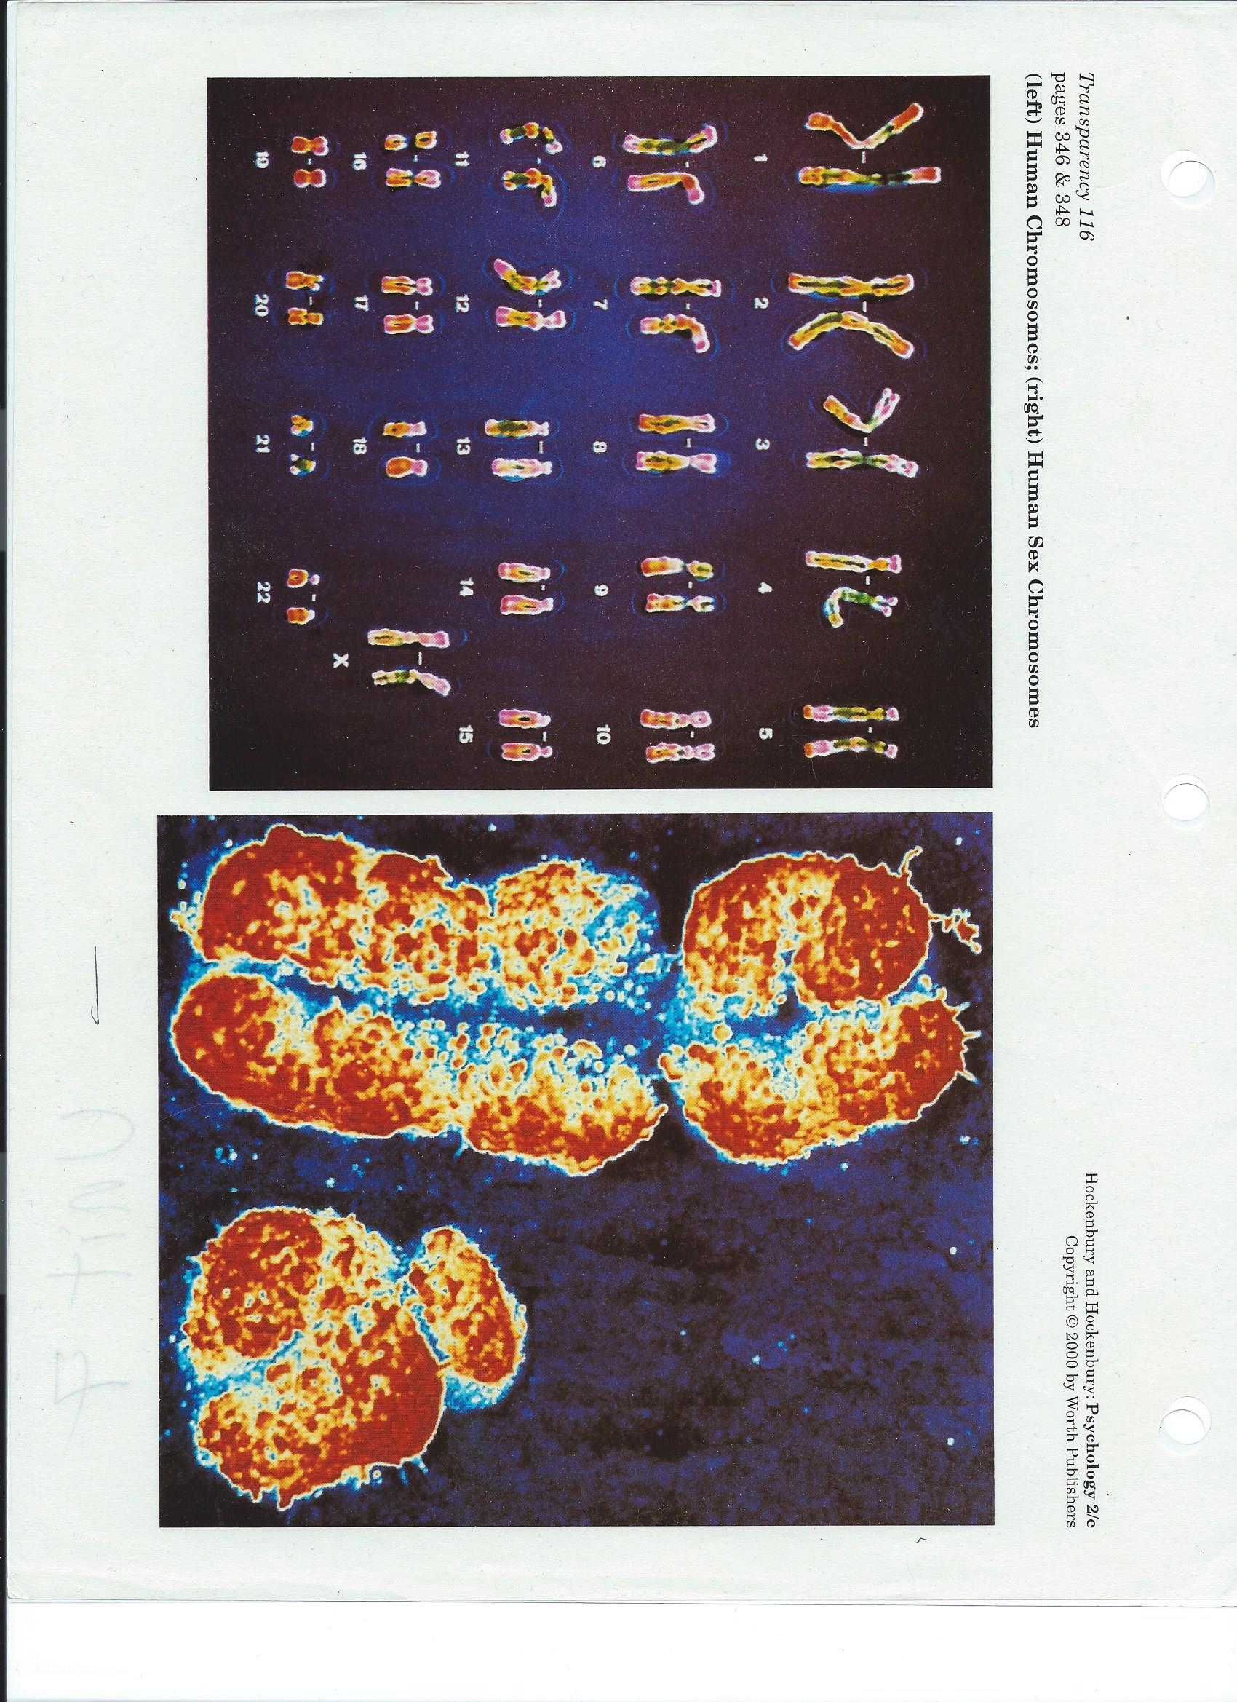
Prenatal Environmental Influences: 337-338

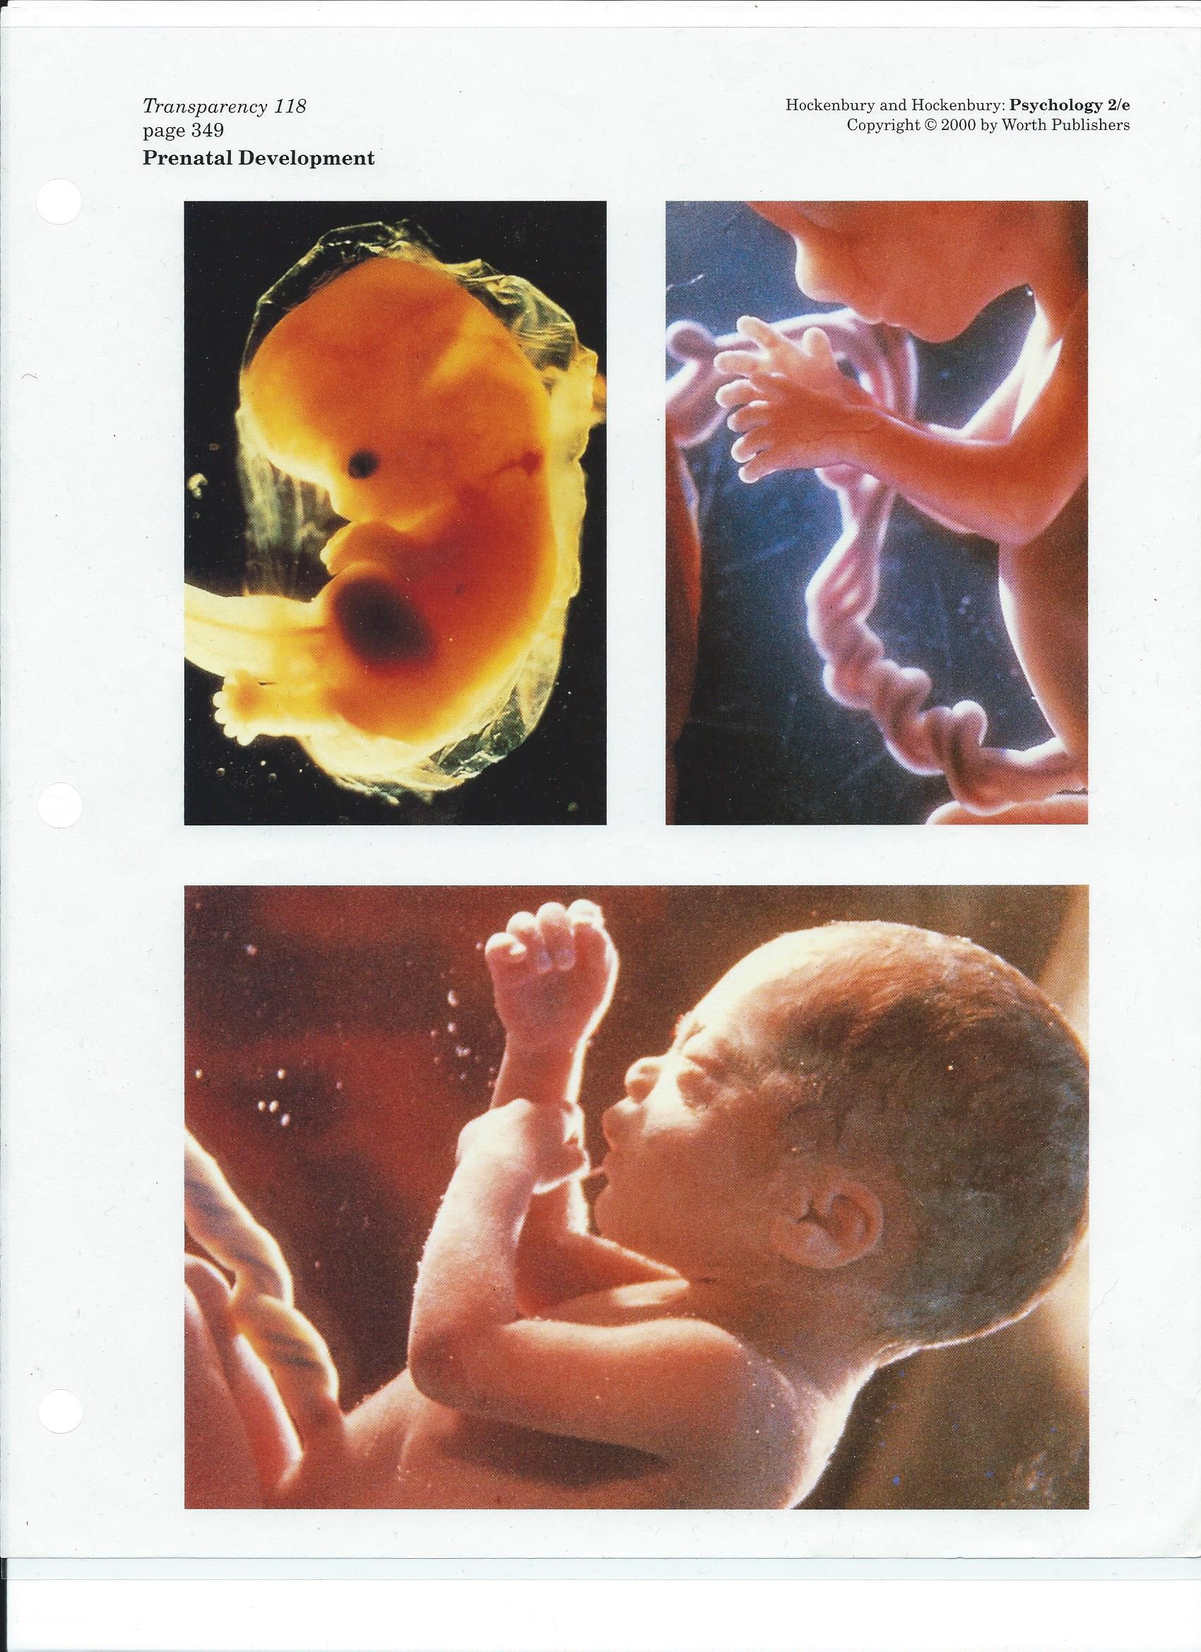
Diet
Teratogens:
x-ray
environmental hazards
pathogens
drugs
Stress
Conditioning
The Newborn: 340-344
Reflexes: startle, Babinski, grasp, rooting sucking swallowing
Senses
Temperament
Activity Level
Easy, Difficult, Slow to warm
Attachment: 344-348: Development of Social Behavior
Secure
Insecure: Avoidant, Ambivalent, Disorganized
Parent-Child Relationships: 248-250: Parenting Styles and Social
Development
Authoritarian, Permissive, Authoritative
Personal-Social Development: Erik Erikson: 350-351, 362-366
Age Stage Theory. 8 Stages
Trust-Mistrust
Autonomy-Doubt
Initiative-Guilt
Industry-Inferiority
Identity-Role Confusion
Intimacy-Isolation
Generativity-Stagnation
Integrity-Despair
Cognitive Development: 351-356
Piaget. Age Stage Theory. 4 Stages
Sensory-Motor
Pre-operational https://youtu.be/FRvVFW85IcU

Concrete Operations
Formal Operations
Moral Development: 360-362 https://youtu.be/FRvVFW85IcU
Stages of Grief and Loss: 377-378
Denial, Anger, Bargaining, Depression, Acceptance

