Unit 9 Expanded Outline
ABNORMAL: Definition – deviation from the norm. pp 453, 454
Distinction between Gifted (also deviation from the norm) and psychological disorders:
Subjective Discomfort, e.g., anxiety
Dysfunction, in work, school, relationships, everyday life

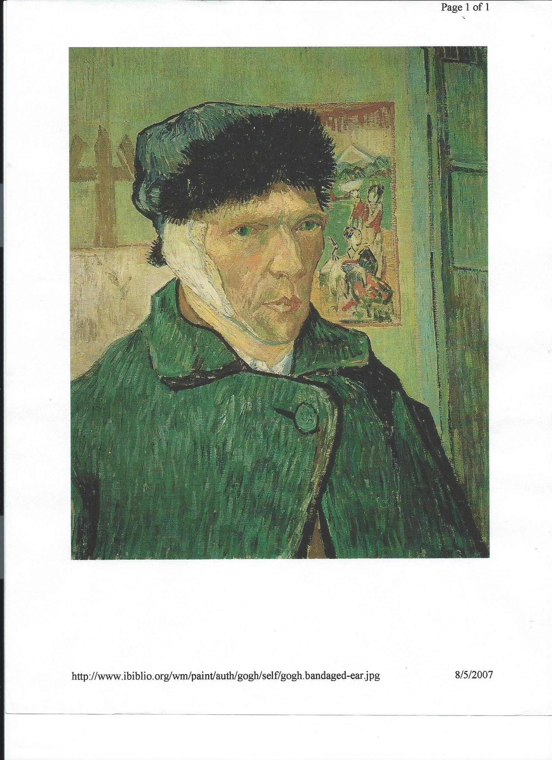

Perspectives 456-458
- Possessed
- Psychoanalysis. 456
- Behaviorism
- Humanism.
- Cognitive Psychology
- Biology/Medical perspective
7. Socio-cultural. Role of family, society, culture, sub culture. Note that Jerry was a police officer
8. Predispositional Model
9. Bio-Psycho-Social Model. Genetic predisposition, personality and social expectations.
e.g. Man with dependent personality (overindulged at the oral stage?) plus social expectation for independence plus genetic predisposition toward depression will lead to depression in this man
10. Eclectic
DSM 458-460
Prevalence: 1 in 2 over lifetime. 30% at any given time.
DISORDERS
Schizophrenia 474
Mood Disorders 470-474
Depression
Bipolar Disorder
Perspectives.
LOSS
Psychoanalysis. 473
Behaviorism.
Cognitive
Biology
Evolutionary Psychology. 473
Why more women than men?
Recent research: Men may express depression through aggressive behavior.
Anxiety Disorders 463-470
Phobia
OCD

Somatoform Disorders
- Hypochondriasis. A special case of? (above)
- Conversion Disorder. La Belle Indifference
Dissociative Disorders
- Amnesia.
- Identity. 470
Personality Disorders. Definition personality? P. 384
Antisocial Personality Disorder
Borderline.
Narcissistic. More common in women
Childhood Disorders
- Bullying. READ p. 470
- Depression
- ADHD
- Autism
Additional Categories: Addiction now in DSM, Eating Disorders, Sexual Disorders

UNIT 9 EXERCISES

