Unit 7 Expanded Outline
Consciousness and Its Altered States
PERCEPTION 116-126
Gestalt Laws
Linear Perspective

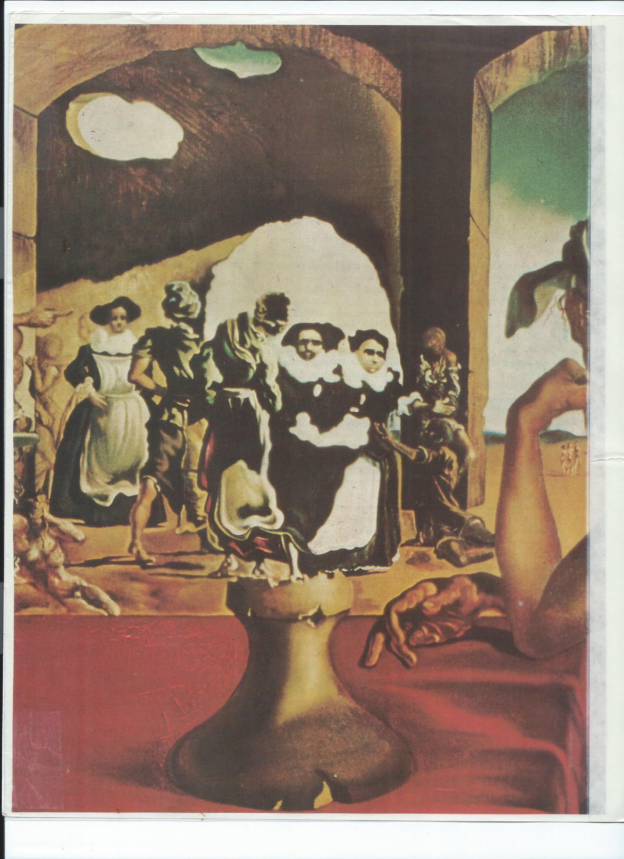
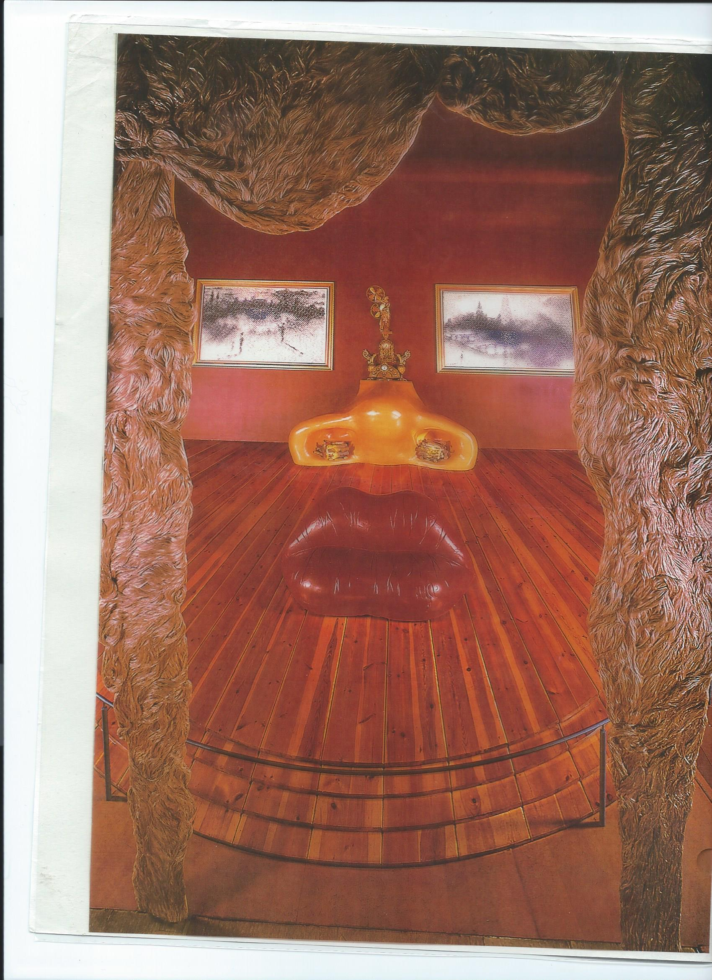
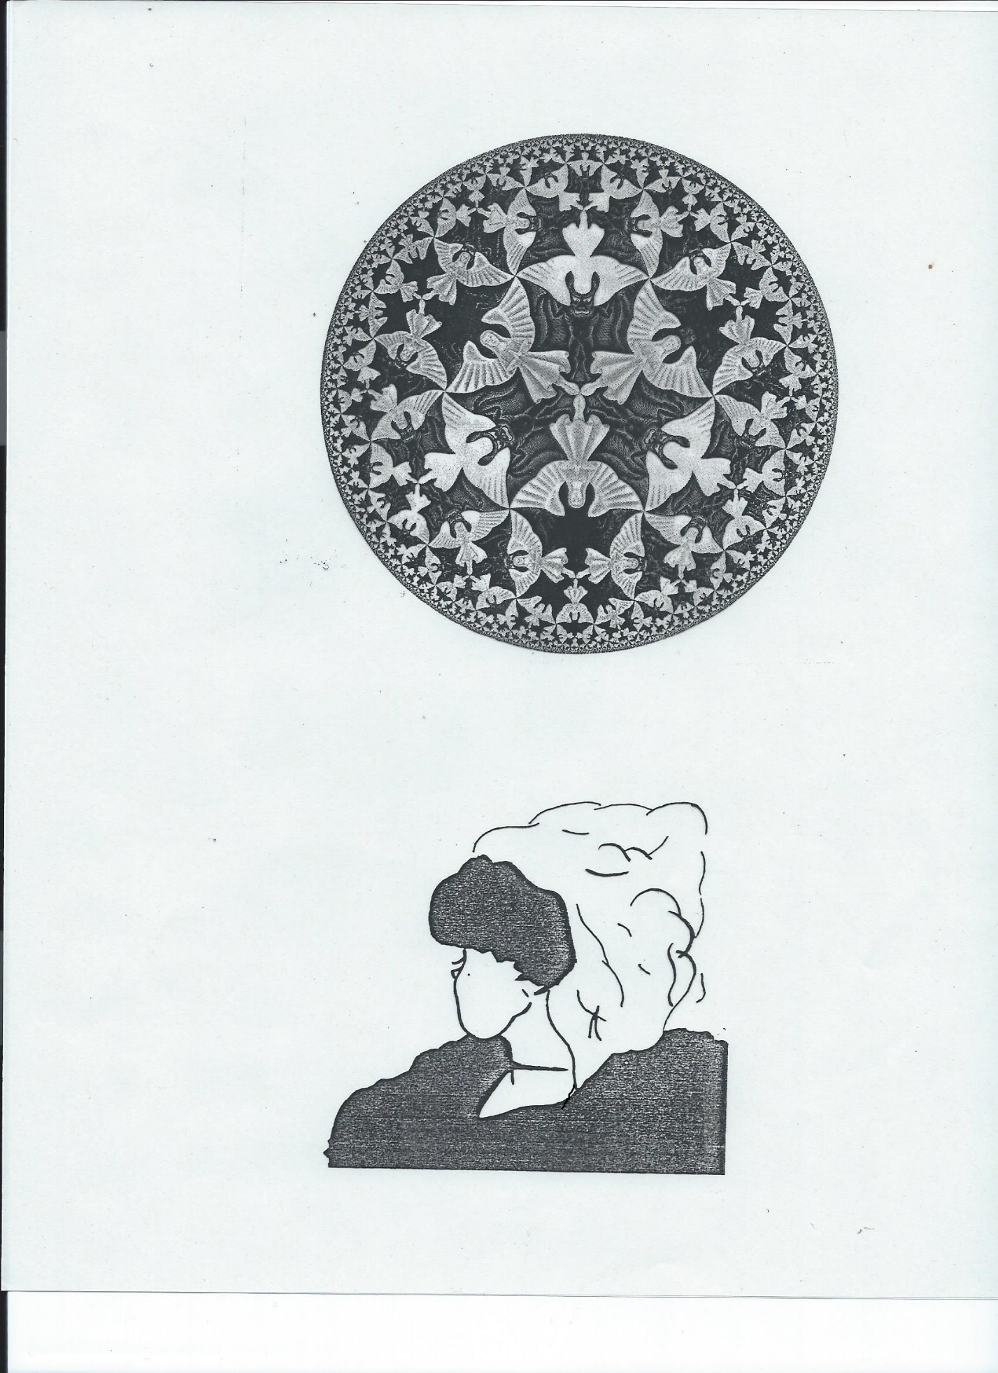
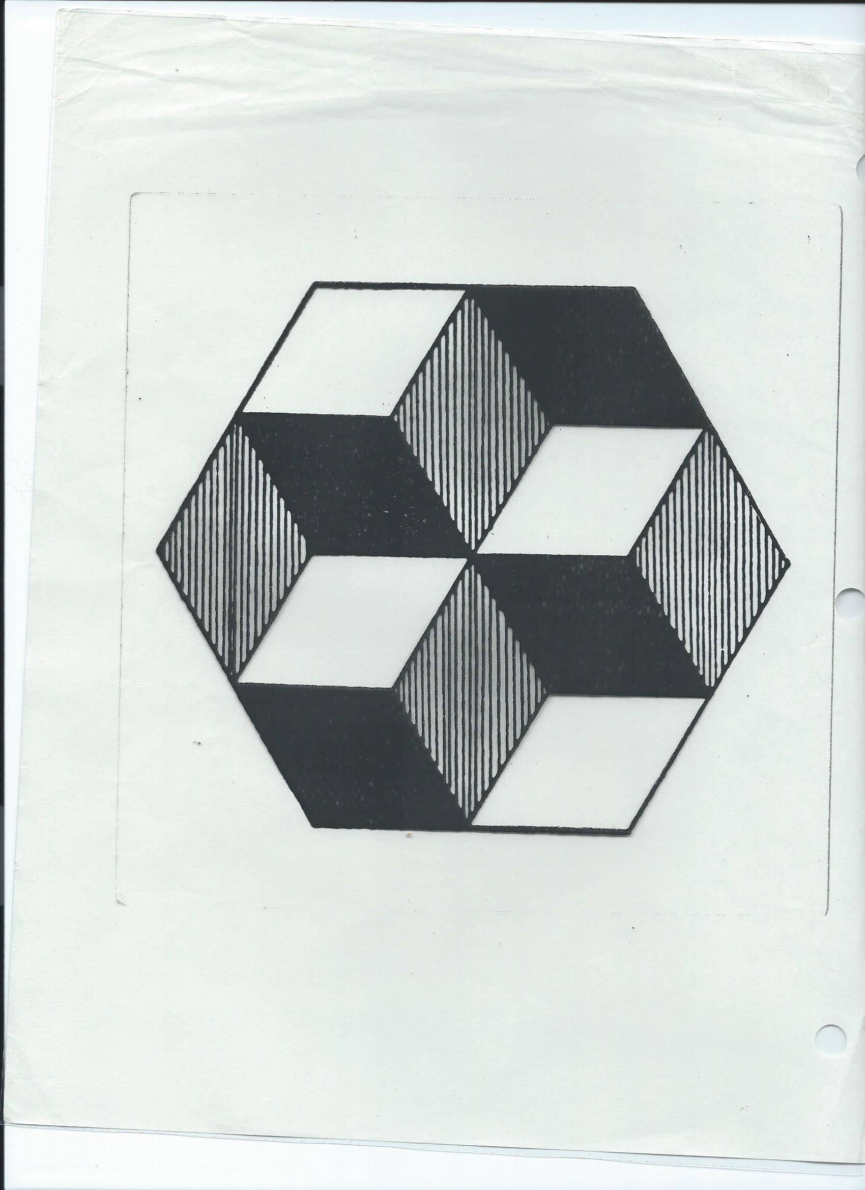
PERSPECTIVES: Psychoanalysis, Behaviorism, Humanism, Cognitive Psychology, Biology, Sociocultural Psychology (e.g. prejudice)
CONSCIOUSNESS definition
CHARACTERISTICS OF ALTERED STATES OF CONSCIOUSNESS
PSYCHOACTIVE DRUGS 152-163
Mode of operation
Factors affecting the effects of a drug
Addiction
Physiological/physical
- Tolerance/habituation
- Physical withdrawal symptoms
Psychological
- Belief cannot function without it
- Drug comes first
- Withdrawal: anxiety, depression, aggression
A slippery slope. SEE p. 162
Students, why use, why addiction?
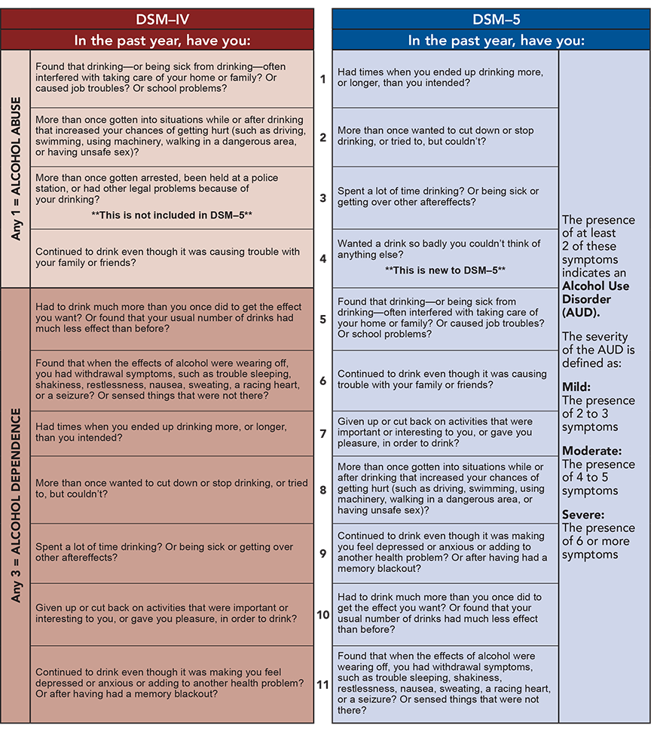

RISK FACTORS FOR ADDICTION
- Genetics; Epigenetics
Behavioral Genetics
Twin Studies, Family Studies , Adoption Studies
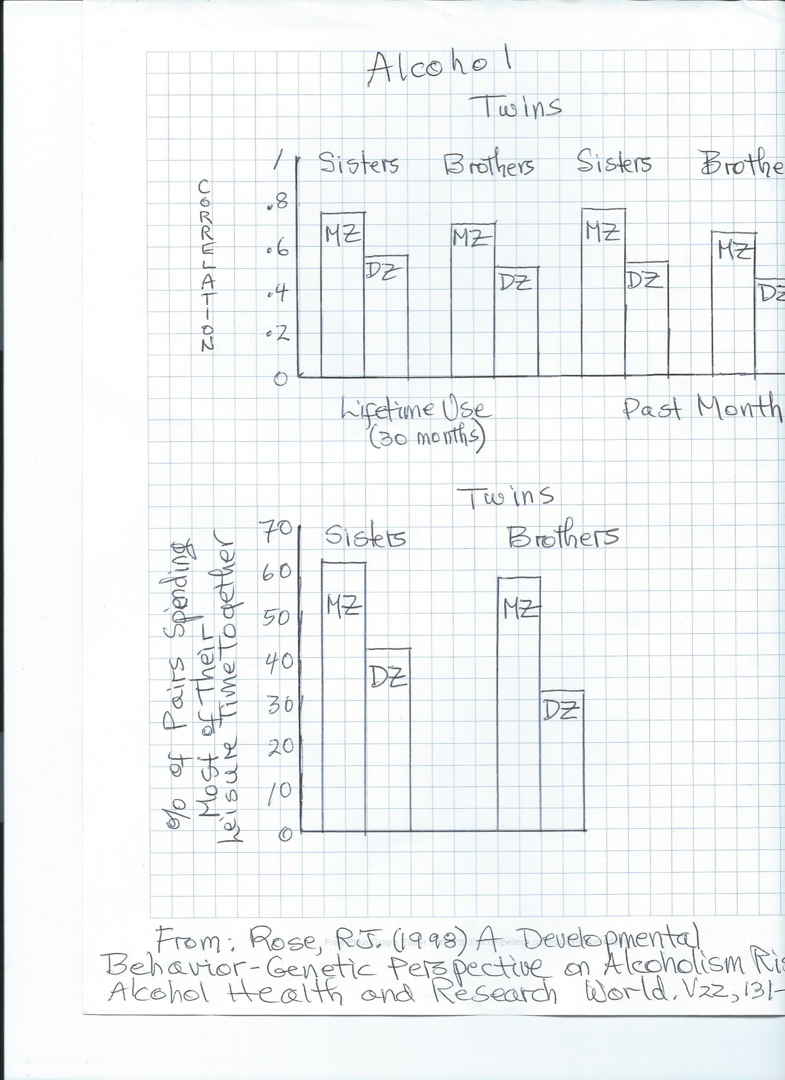

- Personality
Addictive personality
Freud?
- Behaviorism
- Family
Abuse
Drug Use: Vicarious Reinforcment
- Overcoming social inhibitions
- Stress: inner and outer
- Culture
- Drug itself
- Drug availability
- Pre-dispositional Mode
Treatment
- 12 steps
- Psychotherapy
- Controlled Use
- Hypnosis
- Reinforcement for Sobriety
- Pharmacology
Drugs and ASC Characteristics???
DREAMS AND SLEEP 133-145
- Prophetic
- Psychological Health and Hidden Meaning
Freud: Manifest and Latent Content
Displacement
Projection
Distortion
Condensation
Symbols: personal and universal
Jung
Perls
- Activation Synthesis
- Dreams for Survival. P.140
- Fun
REM SLEEP. 20% SLEEP TIME. Pages 134, 135.
Stages of sleep and EEG. Figure 2, p. 134

REM and health. 1. Deprivation and signs of psy disorder
2.Rebound effect
Neurology and Dreams. Prefrontal Cortex less active; Limbic System more active
ASC Characteristics and Dreams???

HYPNOSIS. P. 147
Induction
Susceptibility. P. 147
Neo-Dissociation Theory
Uses:
- Pain control
- Change bad habits
- Psychological disorders
- Criminal investigation
- Improve athletic and exam performance. Note: extra credit opportunity

ASC characteristics???

Students: Healthy ways of altering consciousness?

