Unit 3 Expanded Outline

Unit 3. Humanism: 19, 293-294, 404-406, 507-509
Introduction: 19: The Humanist Perspective
Maslow’s Hierarchy of Needs: 293-294

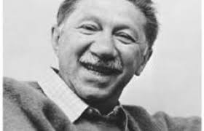

https://youtu.be/MRd-ajUbN98 Masloconditioningw Video

Abraham Maslow concluded that both Psychoanalysis and Behaviorism were inadequate psychological theories: Psychoanalysis is too pessimistic a view of the human Psyche and Behaviorism is too mechanistic a view of the human Psyche. Maslow suggested that we humans are born with a certain amount of inner control (free will) in contrast with Behaviorism, and, that we are born good – compassionate, empathic – in contrast to Psychoanalysis.
Maslow proposed that we humans are born with a set of needs which emerge in hierarchical fashion, from Physiological Needs to the highest need in the hierarchy, the need for Self Actualization. Please note that being the highest need does not mean a more important need, highest in the Hierarchy means all of the other needs must be fulfilled, or mostly fulfilled, before the Need for Self Actualization even emerges.

Hierarchy of needs. See Figure 2, Page 293
Physiological Needs must be fulfilled before the need for Safety emerges.
Physiological Needs: The need for food, water, air, optimal temperature, freedom from pain. For example, if you have a toothache and have not had any food before you go to class, you will probably have difficulty concentrating on class work or anything else until your toothache is relieved and you have something to eat.
Note that food, water, air, optimal temperature are primary positive reinforcements; removal of pain, intense heat and intense cold are primary negative reinforcements
Note that classical conditioning is involved. For example food and pain are Unconditioned Stimuli.

Safety needs must be satisfied before the Need for Love and Belonging emerges
Safety Needs: The need for a safe place to go home to. Your text says safety and security. But, some careers are far from safe and secure, for example, firefighting.

THANK YOU, FIRE FIGHTERS!!!

Two stories that exemplify what I mean:
- I once stayed in a small town near Yosemite, where we love to hike. There was a Fire House across the street. I delighted in seeing the firefighters playing basketball at a nearby hoop.
- One of my students, who is a firefighter, told me they always “debriefed” after fighting a fire.
These stories both exemplify a safe place to go home to.

Love and Belonging needs must be satisfied before the need for Esteem emerges
Love and Belonging Needs: The need to love and be loved; the need to belong.
Love. There are famous people who are loved by millions, but appear not to have satisfied the need to love. I think Marilyn Monroe is a good example. We – my female friends as well as my male friends – all loved Marilyn and yet she appeared (according to biographies) not to have found a relationship in which she was free to give love. The need for love includes loving friends, children, parents, grandparents, famous people. I, for example, was madly in love with Marlon Brando when I was a teenager – saw some of his movies multiple times.
Belonging. Belonging means being part of a group; a group is any number of people from 2 and above. For example, all of us - myself, all of you students - belong to the SRJC community. Other examples: team sports, religious communities, family, romantic partner. I, for example, usually go dancing to live local bands several times a week; there is a group of dancers I see almost every time I go dancing. I am very much belong to that group; I have been sorely missing them since Covid arrived.

Esteem needs must be satisfied before the need for Self Actualization emerges.
Esteem Needs: The need for self-esteem and the need for approval from
others.
Self-esteem means feeling good about oneself, about one’s accomplishments, goals, relationships – to family, friends, humanity in general, feeling good about one’s values and one’s abilities and skills.
Approval from others means getting a positive response from others for one’s accomplishments, goals, relationships.

Self Actualization needs emerge after all of the other needs are satisfied.
Abraham Maslow suggested that Self-actualization is a lifelong process. We don’t become self actualized and sit back and have milk and cookies for the rest of our lives. No. Once the other needs are satisfied than we may start on the path toward self actualization. I like to explain self-actualization by describing some characteristics of the person on the path to self-actualization:
- Human welfare and the earth’s welfare are of prime importance.
- Unconventional: the person on the path to self-actualization is willing to be unconventional, even break the law, in the name of human and/or the earth’s welfare. Examples would be Ghandi, Martin Luther King.
- Relatively fearless, adventurous.
- Creative. By creative, I mean the same as I suggested for sublimation: Creativity means finding a new solution to an old problem and/or finding a solution to an unsolved problem.
- More peak experiences than others. Peak experience: a sudden feeling of elation, not brought on by anything external

Example: Julia Butterfly was a woman who climbed to the top of a
Redwood try to save the trees. She stayed there for an unbelievable amount of time through rain and windstorms. She was unconventional, fearless and the Earth’s welfare was of prime importance to her.

Please Note: Being on the Path to Self Actualization does not mean you display these characteristics every minute of your life. Let’s say I am on the path. When I have an argument with my boyfriend and I stomp out of his house (to return a few minutes later), for those moments I am not on the path. If I get busy and forget lunch, around 3 o’clock, all I can think of is food – I am momentarily off the path. Being on the path means being there most of the time, not every minute.

Please Note: Not everyone who seems to have fulfilled the needs through Esteem appears to start on the path to Self Actualization.
Please Note: Physiological Needs and Safety Needs are considered to be “Deficiency Needs”; Love and Belonging, Esteem, and, Self-Actualization Needs are “Growth Needs”.

Carl Rogers and Client Centered/Person Centered Therapy: 507-509: Humanistic
Therapy

https://youtu.be/o0neRQzudzw Carl Rogers Video

Rogers suggested that, since we humans are born good and with a certain amount of inner control, we can solve our own psychological problems if we are provided with a non-judgemental atmosphere. This led to the development of what Rogers originally called Client Centered Therapy.

Carl Rogers
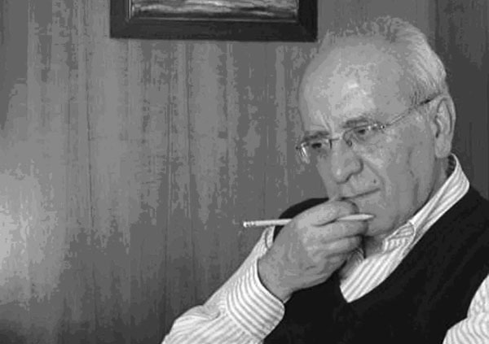
Carl Ransom Rogers was one of the most prominent figures in the history of psychology, well known as the founder of humanistic approach. His influential works have given way to new dimensions in psychology and created a profound impact on psychotherapy, counseling and education. He was born on January 8th 1902 in Chicago, Illinois.
Rogers received his early education in a religious environment followed by studying scientific methods and its application in a practical world. He chose agriculture as his first field of study at University of Wisconsin-Madison, followed by history and religion. Then, he went on to attend International Christian Conference at age 20, after that he decided to change his career paths and attended Teachers College at Columbia University from where he obtained his MA in 1928 and PhD in 1931. After completing his work for PhD degree he engaged himself in child behavioral studies where he held office as the director of The Society for the Prevention of Cruelty to Children in New York. Serving as a professor of psychology at University of Chicago he got elected as the president of American Psychological Association. During this period he also wrote “On Becoming a Person: A Therapist’s View of Psychotherapy” in 1961.
He worked with Abraham Maslow in laying grounds for humanistic psychology, the major applications of his theory included person-centered therapy, learner centered teaching, cross cultural relations and rogerian rhetorical approach. The theories that he presented on self consisted of 19 propositions, the first one said that every living organism had a sense of their well-being, they know what was threatening or nourishing for them. He termed this notion as organismic valuing. He proposed this idea based on evolution according to which man understands and differentiates between his needs and their fulfillment. Positive regard is the most valuable emotion among humans which includes all the positive emotions like love, appreciation, affection, respect and attention to lead a prosperous and successful life. Positive regard also gives way to nurture positive self-regard which is the self-esteem of a person, what he perceives himself to be in his own eyes, how he values and worth himself.
Carl Rogers used the term person-centered approach to devise applications related to personality theory, interpersonal relations, cross cultural relations and professions like nursing and teaching that need extensive human care and support. Person centered approach was initially named as client centered approach, this approach was devised when Carl Rogers was conducting therapeutic sessions with his clients. His helper, Elias Porter measured the employment of directiveness and non-directiveness by the counselor in maintaining the effectiveness standard of the therapy. Learner centered teaching was another concept that Roger devised and emphasized upon by concluding that learning occurs in a free environment. He wrote “Freedom to Learn” in 1969 to describe this theory. American Psychological Association recognized his works and bestowed him with an Award for Distinguished Scientific Contributions in accreditation for his exemplary works to the field of psychology. Also, he was awarded with Humanists of the Year in 1964 by American Humanist Association. He had the honor of being the sixth prominent psychologist of 20th century.
Client Centered therapy

Rogers suggested that, since we humans are born good and with a certain amount of inner control, we can solve our own psychological problems if we are provided with a non-judgemental atmosphere. This led to the development of what Rogers originally called Client Centered Therapy.

Non Judgmental Atmosphere
Unconditional Positive Regard. The therapist accepts whatever the client says with an important exception: If the client talks about harming self and/or others, the therapist must call in appropriate authorities.
Active Listening: Paraphrasing or restating what the client says. Violations of Active Listening includes expressing sympathy, lecturing, giving solutions to the client’s problems.

Peaceful Conflict Resolution
- All parties in conflict take turns speaking and actively listening.
- All parties in conflict independently note down possible solutions.
- Solution common to all parties is chosen.

