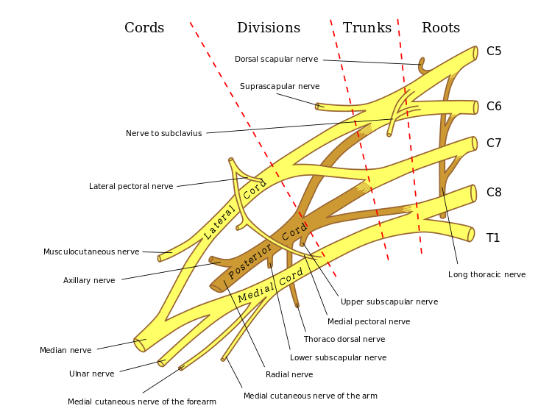

17._________________________

2.________________

10.____________________

11._______________________________________

9.___________

8.___________

7.___________

6.___________

5.___________

3.___________

1._____________

18.____________________

16.____________________

12._________________

13._______________

15._______________________

14.____________________

4.___________