How to do Statistics Analysis for Arabidopsis.
Analysis of Variance (ANOVA)
We are going to analyze our data using an ANOVA. The basic premise is that we are comparing the amount of variation between treatments ( the different % hydration for example) than within treatments (the plants in one particular % hydration).

We are doing a two way ANOVA since we considered % hydration AND time soaking. But there could be an interaction between these factors. Maybe the time soaking makes more of a difference at lower % hydrations….

We are looking for a statistically significant difference between our treatments. This means we can only conclude that there is a difference between our treatments if there is a less than 5% chance of being wrong. (p< .05)
How to Calculate
- Open up the data sheet with either fruit or rosette diameter data

- Add in the XL Miner Toolpak
- Click on Add-ons and from drop down menu, select ‘’Get Add-on’’

- Find and select XL Miner Toolpak and it will be available to you in the drop down menu.

- XL Miner Toolpak
- Now that you have added it into your Google Sheets, select XL Miner from the dropdown menu ‘’Add-ons’’.
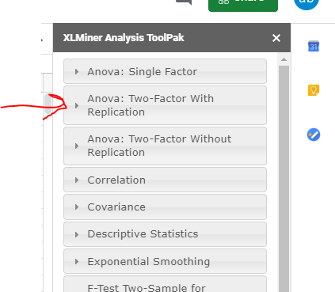
- You will see the menu for this Add-on on the left side of the screen.
- Click on Two Way ANOVA with replication
- That will open up and look like this below

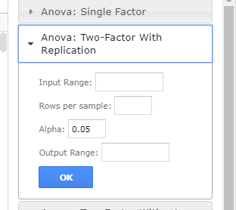

- Doing ANOVA
- Input Range: select the cells that contain the data – make sure to include the column with % hydration and the header with time.
- Rows per sample: this is the number of samples for each treatment and should be 18
- Output range: when you click in this box, it automatically puts the range that you selected for your data. This means it will paste your ANOVA table over your data- which is weird and I don’t like. Make sure to click in an empty cell that has lots of empty space above and below so that you can read your output easily.

- Interpreting your ANOVA Summary
- This is super useful since it gives you the average for each of your treatments. You can take this information and use that to make your bar graphs.
- For example, I can graph the average fruit number for 20-30% at 5 min, 10 min, etc

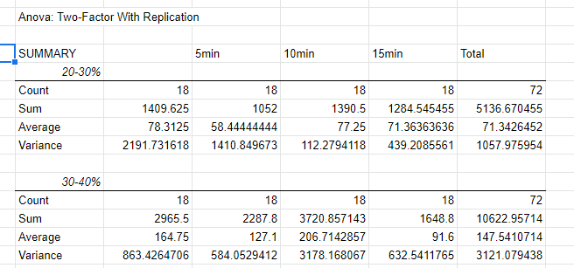

- Interpreting your ANOVA table;
- Sample= the rows = % hydration
- Column = time
- P-value = is the chance that we are wrong if we conclude that there is a significant difference between treatments. If it is less than .05, then we conclude there is a difference.
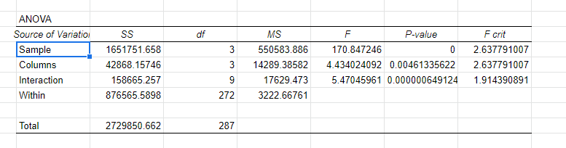
- In this case below, you can see that there is a significant difference for Sample (% hydration), Column (Time) and Interaction.
- That doesn’t tell us which treatments differed – for that we’ll need another statistical test called a Tukey’s t-test.
- I will do that and distribute in class.

