SYLLABUS
FOR
FIRE 72:
FIRE BEHAVOIR
&
COMBUSTION
Online COURSE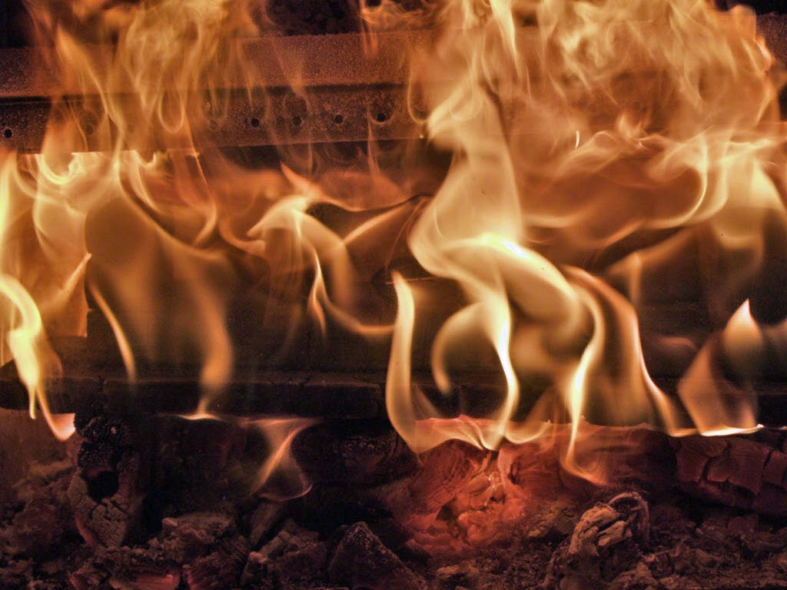

Introduction

WHAT THIS CLASS IS ALL ABOUT

This course is structured to give the student, who is in the fire service or is striving to get into the fire service, the knowledge of the behavior of fire and the laws that govern said behavior. The class will be technical in nature, but degree of difficulty will be such that it will not be hard for those students who make an honest effort in the class. The class will involve a lot reading and studying. The information is going to be presented in a manner that relates to what will be encountered in the field of firefighting.
Important Points:
- Complete assignments on time to avoid losing points toward your final grade.
- Due to technical nature of the course, you must complete “reading assignments.” prior to the On-line lecture. The On-line lecture is to clear up concepts or points in need of further explanation.
- You need to study “the specific On-line lecture notes and chapter” prior to the quiz. If you “study”, you will have a much better chance of passing the quizzes. Please Note! You will have certain time limit to take the given quiz (30 minutes) in time and the quiz will be on the website for 5 days!

For those of you taking this course, you will be embarking, on a course of study, which affords a great deal of freedom. However, this freedom requires a great deal of discipline and dedication to the course work. This is the type of class work, if you fall behind, you will have hard time to catch back up on your work. The DEADLINES are as with any other college level course of study, FIRM. You will know from the first day of class when all assignments are due. The form of notification will be the following: Web-site, syllabus and reminders from me via e-mail and postings on the “website” under “announcements” as an assignment date gets closer. (Under “announcements” is simply general e-mails sent to everyone but is duplicated on the website)

In the event, you had not taken any On-line classes; you can take an introduction class seminar to “How to succeed On-line.”

REQUIRED TEXT FOR COURSE

The text we will be using for this class will be the following:

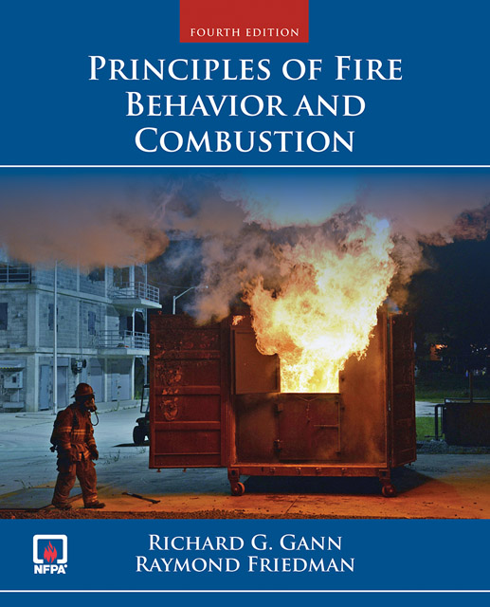
Principles of Fire of Fire Behavior and Combustion Fourth Edition
Richard G. Gann & Raymond Friedman
ISBN 978-0-7637-5717-5

CONTACT INFORMATION

I will be available at the stated times on the on the “schedule page” and by appointment to help student(s) if needed.

Also, you may contact me by the following means:

Home Phone: (415) 898-4640

Fax: Same as above

E-mail: tavraham@santarosa.edu Primary Email
tzahalbenavraham@verizon.net Secondary

Office Hours: By Appointment
- If I am away from the phone, you should leave your name and contact phone number, so that I may return your call.

Sincerely,

Tzahal Ben Avraham, Instructor Fire 72 Santa Rosa Junior College

Table of Contents

The following is listing of the documents that are part of the aforementioned syllabus:

- Expectations/Grading (Student Learning Outcomes-SLO)

- Class Dates for the given Section and Day

- Guidelines for the Definitions & Term Paper

- Guidelines for “Final Project” Pending

You are responsible to read and understand these documents. If you are not clear on any points in this syllabus, you need to contact me to clarify. I look forward to working with you all this semester.

Sincerely,

Tzahal Ben Avraham, Fire 72 Instructor, SRJC

Document

One:
Expectations/Grading and SLO or Student Learning Outcomes

This page is left blank
Intentionally!

GRADES & SCORING

Each student’s Final Grade will be derived from the following: (refer to the “Grade Work Sheet for Fire 72 in the body of this syllabus for point break down)

How Grades are calculated
A 90% 540 points or more
B 80% to 89% 480 to 534 points
C 70% to 79% 420 to 474 points
D 60% 360 to 69% to 414 points
The points will be based on the following:
Quizzes: | 260 points or 40%
Definitions' Assignment: | 115 points or 20%
Term Paper: | 115 points or 20%
Final Project: | 115 points or 20%
Total for the above: | 605 points (Not including Bonus points)
BONUS POINTS

Bonus Points will be provided on Quizzes from time to time and to Assignments that have been completed to a superior standard. In addition, “Special Opportunities” as provided by the Instructor will be awarded.

The Bonus Points will be added to the Student’s Aggregate Points applied to the Final Grade. To take full advantage of the bonus points, you must turn in your work assignments on time!

MAKE UP QUIZZES

The Instructor will not make up quizzes. Unless prior arrangement as been made and agreed upon the instructor. REMEMBER, YOU HAVE A EIGHT DAY WINDOW TO TAKE A QUIZ. All the quiz “window days” are listed on the Web- site and in this Syllabus under, “Class Time Line, Official”

Note, you the student are required to drop from the course, in the event; you are unable to complete the class. This action on your part will prevent you from getting a sub-par grade at the end of the semester. You are expected to Check In to class and complete your lectures and quizzes on time! Treat this class as if you are showing up to a place of work, for example, a shift at the firehouse!

Student Learning Outcomes:
1. Define basic terms and concepts related to fire behavior and chemistry.
2. Identify states of matter and describe chemical processes associated with combustion.
3. Analyze physical conditions which determine states of matter and influence fire behavior.
4. Describe fire suppression agents and their properties.
5. Compare and contrast methods and techniques of fire suppression.
Objectives:
Upon completion of the course, students will be able to:
1. Summarize the impact of fire in the United States
2. Describe the activities conducted by fire research agencies
3. Identify the systems of measurement used in the scientific study of fire behavior
4. Describe the difference between matter and energy
5. Identify the three physical states of matter
6. Summarize the nomenclature used in the scientific study of fire behavior
7. Describe the chemistry of natural fire combustion
8. Summarize the laws of thermodynamics and heat transfer
9. Describe the three modes of combustion
10. Distinguish between the different types of ignition and the factors that influence them
11. Analyze the chemistry of flame spread as it relates to fire behavior
12. Define the concept of burn rate and the variables that effect its performance
13. Identify the common products of combustion and their hazards
14. Describe the development of fire in an enclosed environment and the influence of smoke
movement and ventilation
15. Describe the most effective suppression methods on the various classes of fire
16. Identify the environmental factors that affect the start and spread of a wildland fire
17. Define explosive fire behavior and distinguish between the different types of explosions
Topics and Scope:
I. Introduction To The Study Of Fire
A. History of fire
B. Natural causes of fire
C. Fire's impact on society
D. Fire research
E. Systems of measurement
II. Matter and Combustion
A. Matter
B. Properties
C. Chemical change
D. Conservation of mass and energy
E. Types of natural fires
F. Combustion in natural fires
III. Heat Transfer and the Three Theories of Fire
A. Thermodynamics
B. Heat Transfer
C. The theories of fire
IV. Ignition
A. Piloted and auto ignition
B. Humidity chemical kinetics
C. Evaporation
D. Boiling point
E. Flammable limits
F. Flash point
G. Spontaneous combustion
H. Solid fuels ignition
V. Flame Spread
A. Smoldering and flaming combustion
B. Surface combustion
C. Flame and fire spread
D. Wind aided and opposed flow
E. Pyrolsis
F. Flame spread on solid surfaces
G. Flame spread on porous arrays
H. Flame spread on liquids
I. Typical spread rates
J. Standard test methods
VI. Burn Rates
A. Mass loss rate
B. Mass burn rate
C. Mass burning flux
D. Burn rate variables
E. Heat of gasification
F. Energy release rates
VII. Combustion Products
A. Chemical composition
B. Burn process
C. Yields
D. Concentrations
E. Hazards
VIII. Compartment Fires
A. Stages of fire development
B. Compartment dynamics
IX. Extinguishment Theory
A. Classes of fire
B. Methods of extinguishment
X. Wildland Fire Behavior
A. The fire triangle
B. Modes of heat transfer
C. Environmental factors
D. Fuel types and factors
E. Topography
F. Fire weather
XI. Explosive Fire Behavior
A. Types of explosions
B. Cause of explosions
C. Explosion reaction
D. Strength of explosives
Representative Assignments:
1. Reading 10-20 pages per week in textbook, the use online presentation material to round out the course work.
2. Research paper
3. Glossary assignment
4. Final Project Online class
5. Oral presentation evaluations for the face to face classes (Final Project) for the online class
6. 14 quizzes

Grade Work Sheet for Fire 72

What are the values of the “assignments” .
Quiz | Topic of Quiz | Points for Quiz
Quiz 1 | Chapter 1 | 20
Quiz 3 | Chapter 3 | 20
Quiz 4 | Chapter 4 | 20
Quiz 5 | Chapter 5 | 20
Quiz 6 | Chapter 6 | 20
Quiz 7 | Chapter 7 | 20
Quiz 8 | Chapter 8 | 20
Quiz 9 | Chapter 9 | 20
Quiz 10 | Chapter 10 | 20
Quiz 11 | Chapter 11 | 20
Quiz 12 | Chapter 13 | 20
Quiz 13 | Wild-land Fire | 20
Quiz 14 | Explosive Fire | 20
Definition Paper | “ “>>>>>>> | 115pts
Term Paper | “ “>>>>>>> | 115pts
Final Project | “ “>>>>>>> | 115pts
Total of above | “ “>>>>>>> | 605 points
Please Note! Bonus Points are to be added to your final grade. If you should get bonus points on a quiz, the points will be added to the quiz score.
Quizzes | 40% of Grade | 260 points
Term Paper | 20% of Grade | 115 points
Definitions Assign… | 20% of Grade | 115 points
Final Project | 20% of Grade | 115 points
Grand Total | W/O Bonus points | 605 points possible

Document Four:

Class Dates for the given Section and Day

This page is left blank
Intentionally!

Class Time line (Official) for The Spring Semester of 2018

Week 1 | Topic of the Week (Jan. 17-19, 2018) | Quiz to be given | Date
Syllabus | Orientation/Syllabus | Bonus Quiz | Jan. 21-28, 2018
Week 2 | Topic of the Week (Jan. 22-26, 2018) | Quiz to be given | Date
Class Time line (Official) for The Fall Semester of 2018
Week 1 | Topic of the Week (Aug. 20-24, 2018) | Quiz to be given | Date
Syllabus | Orientation/Syllabus | Bonus Quiz | Aug. 26-Sept. 2,2018
Week 2 | Topic of the Week (Aug. 27-Sept. 3, 2018) | Quiz to be given | Date
Chapter 1 | Fire Measurement and the SI system of Meas. | Chapter 1 Mat… | Sept. 2-9, 2018
Week 3 | Topic of the Week (Sept.3-7, 2018) | Quiz to be given | Date
Chapter 3 | Physical and Chemical Change | Chapter 3 Mat… | Sept. 9-16, 2018
Week 4 | Topic of the Week (Sept.10-14, 2018) | Quiz to be given | Date
Chapter 4 | Flow of Fluids | Chapter 4 Mat… | Sept. 16-23, 2018
Week 5 | Topic of the Week (Sept. 17-21, 2018) | Quiz to be given | Date
Chapter 5 | Heat Transfer | Chapter 5 | Sept. 23-30, 2018
Week 6 | Topic of the Week (Sept. 24-28, 2018) | Quiz to be given | Date
Chapter 6 | Combustion, Fire and Flammability | Chapter 6 Mat… | Sept. 30-Oct. 7, 2018
Week 7 | Topic of the Week (Oct.1-5, 2018) | Quiz to be given | Date
Chapter 7 | Fire Characteristics: Gaseous Combustibles | Chapter 7 Mat… | Oct.7-14, 2018
Week 8 | Topic of the Week (Oct.8-12, 2018) | Quiz to be given | Date
Chapter 8 | Fire Characteristics: Liquid Combustibles | Chapter 8 mat… | Oct. 14-21, 2018
Week 9 | Topic of the Week (Oct.15-19, 2018) | Quiz to be given | Date
Chapter 9 Pt 1 | Fire Characteristics: Solid Combustibles Pages 130 through 150 | Chapter 9 Mat… | No quiz this week
Week10 | Topic of the Week (Oct.22-26, 2018) | Quiz to be given | Date
Chapter 9 Pt 2 | Fire Characteristics: Solid Combustibles Pages 151 through 171 | Chapter 10 Mat… | Oct.28-Nov. 4, 2018
Week 11 | Topic of the Week (Oct. 29-Nov. 2, 2018) | Quiz to be given | Date
Chapter 10 | Combustion Products | Chapter 10 Mat. >>> | Nov. 4-11, 2018
Week 12 | Topic of the Week (Nov.5-9, 2018) | Quiz to be given | Date
Chapter 11 | Smoke and Heat Hazards | Chapter 11 Mat… | Nov. 11-18, 2018
Week 13 | Topic of the Week (Nov. 12-16, 2018) | Quiz to be given | Date
Chapter 13 | Fire Fighting Chemicals | Chapter 13 Mat… | Nov. 18-25, 2018
Week 14 | Topic of the Week (Nov. 26-30, 2018) | Quiz to be given | Date
Online Lecture | Wild Land Fire Behavior | Wild-land Presentation | Dec. 2-9, 2018
Week 15 | Topic of the Week (Dec. 3-7, 2018) | Quiz to be given | Date
Online Lecture | Explosive Fire Behavior | Explosive Fire  Presentation | Dec. 9-16, 2018
Week 16 | Topic of the Week (Dec. 10-14, 2018) | Quiz to be given
Lect. Notes | Bonus Lecture: The Great Fires | Bonus Quiz | Dec. 16-23, 2018
Week 17 | Topic of the Week Dec. 17-21, 2018) | Final Project | Date Due
&final Week | Work on final project… | Complete by due date | Dec. 17, 2018

Assignments and their Due Dates- MUST BE SUBMITTED BY THE DATES BELOW!!
Assignment | Due Date
Definitions’ Assignment | * (Oct. 19, 2018) [Week 9]
Term Paper | *(Nov. 16, 2018) [Week 13]
Final Project | Dec. 17, 2018
Remember!! Late Works | Will not be accepted!

This page is left blank
Intentionally!

Document Four:
Guidelines for the Definitions & Term Paper

This page is left blank
Intentionally!

The first of the “written assignments” is going to be the Definitions Assignment.

The work is to be constructed as follows:

- The work is to be “word processed or typed”.
- You can use #12 or #14 font size and must be doubled spaced between the definitions.
- This is to be a research type paper. You can use the following sources to acquire the information to complete the work:
  - The library may be public, college, or firehouse, etc.
  - Trade publications
  - The internet has many websites
  - Professionals in the field of science, etc
  - Some of the Definitions can be found in the Textbook and Lecture Notes

The sources that are used need to be properly cited. Please refer to the examples in this syllabus under “written assignment guidelines”

Remember, late papers will not be accepted (emergencies will be evaluated on case by case basis). All members of the class will know the due dates of the assignments on the first night of class. The due dates are on the “Class Dates and Topics Fire 72”

This paper is worth 10% of your final grade. I can not overstate the importance of turning in your work on time!

Some basic ways you can do the layout:

Title Page: Example 1:
Fire 72: Fire Behavior and Combustion

Definitions assignment
By

Jane Doe

04/08/05
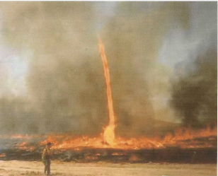
You may insert graphics into your title page as illustrated.

Title Page: Example 2:
Fire 72: Fire Behavior and Combustion
Definitions assignment
By

Jane Doe

04/8/05

Definition Layout Examples:

Example 1:
Thermosetting Plastic- “This type of plastic is where the chains that bond this polymer tend to char upon heating” (Avraham, Burning Rate, 4). Note you can foot note your quotes as illustrated in the example.
Example 2:
34) Thermosetting Plastic- “This type of plastic is where the chains that bond this polymer tend to char upon heating” (Avraham, Burning Rate, 4). This is the best way by placing the number of the definition in front. This action makes my job easier in the correction process. Also, by numbering the terms, you will less apt to forget any of the terms from your assignment!! (Examples 1 & 2 courtesy of Robert Crane Fall 04)
Basic Bibliography Layout:
Example 1: (As done from a direct publication)
International Fire Service Training Institute. Essentials of Fire Fighting 4th
Edition. Oklahoma: Oklahoma State University, 1998.
Hopkins, Ron. Explosion Incidents: The Company Officer’s Role. Nov. 1999.
TRACE Fire Protection and Safety Consultants, Ltd.

Works Cited:
Dictionary.com. 2004. Lexico Publishing Group, LLC. 5 Oct. 2004.
http://www.dictionary.reference.com.
Hopkins, Ron. Explosion Incidents: The Company Officer’s Role. Nov. 1999.
TRACE Fire Protection and Safety Consultants, Ltd.
http://www.fireandsafety.eku.edu/VFRE.pp/Default.htm.
Hyperdictionary. 2000-2003. Webnox Corp. 5 Oct. 2004.
<http://www.hyperdictionary.com/.>
International Fire Service Training Institute. Essentials of Fire Fighting 4th
Edition. Oklahoma: Oklahoma State University, 1998.
Klinoff, Robert. Introduction To Fire Protection 2nd Edition. USA: Thomson
Delmar Learning, 2003.
Merriam-Webster Medical Dictionary. 2003. Merriam-Webster, Inc. 5 Oct. 2004
http://www.intelihealth.com/IH/ihtIH/WSIHWOOO/9276/9276.html.
Physical Environment>Chemical Energy. 2002. Penny Press, Ltd. 5 Oct. 2004
<http://historyoftheuniverse.com/chemene.html>.
Quintiere, James G. Principles of Fire Behavior. Albany: Delmar, 1998.
Avraham, Tzahal. Fire 72 Notes. 2004. Santa Rosa Junior College.
U.S. Department of Labor. 5 Oct. 2004. Occupational Safety and Health
Association. 5 Oct. 2004. http://www.osha.gov/SLTC.smallbusiness/SEC8.html.
WordIQ.com. 2004. WordIQ.com. 5 Oct. 5004.
<http://www.wordiq.com/dictionary.html?source=enhance>.

Example 2: (As done from an internet source)

This is an example how a bibliography page should look like.
(Bibliography Page Courtesy Robert Crane Fall 04 Fire 72 Class)

Please refer to the following list of “definitions”.

Definitions:

- Chemical Properties:

- Physical Properties:

- Element:

- Compound:

- Chemical Change/Reaction:

- Physical Change:

- Combustible Liquid (provide examples):

- Flammable Liquid (provide examples):

- Combustible Metals (provide examples):

- Carboxyhemoglobin:

- Chemical Energy (provide examples of the two types):

- Concentration:

- BTU:

- Joule:

- Fire:

- Fire Point:

- Fire Tetrahedron:

- Fire Triangle:

- Flame:

- Dry Chemical Extinguishing agent and how it works:

- Flammable Range/Explosive Range:

- Flammable Solid:

- Flash Point:

- Heat:

- Heat Capacity:

- Heat of Combustion:

- Heat of Combustion {effective}:

- Fire stages: As the fire would develop in a structural environment!

- 1st or Incipient
- 2nd Stage
- 3rd Fully Developed or Back-draft if (ventilation limited)

- Pyrophoric Material:

- Radiant Energy:

- Spontaneous Combustion:

- Temperature:

- Thermoplastic:

- Thermosetting Plastic:

- Vapor:

- Vapor Density:

- Vaporization:

- Vapor Pressure:

- Low Explosive (provide examples): Do not confuse with Explosive Range/Flammable range of Fuel air gas mixtures!!

- High Explosive (provide examples): Do not confuse with Explosive Range/Flammable range of Fuel air gas mixtures!!

The Second of the “written assignments” is going to be the Term Paper.

The work is to be constructed as follows:

- The work is to be “word processed or typed”.
- You can use #12 or #14 font size and must be doubled spaced between the thoughts or paragraphs.
- The Term Paper can be no shorter than three page [text pages] or longer than five pages. You must incorporate an image or drawing into the paper by digital means or by hand that supports your topic. You can use the following sources to acquire the information to complete the work:
  - The library may be public, college, or firehouse, etc.
  - Trade publications
  - The internet has many websites
  - Professionals in the field of science, etc

The sources that are used need to be properly cited. Please refer to the pamphlet available at the campus library on the subject.

Remember, late papers will not be accepted (emergencies will be evaluated on case by case basis). All members of the class will know the due dates of the assignments on the issuance of this syllabus. The due dates are on the “Class Dates and Topics Fire 72” Your paper must be post marked no later than the date stated on
“Class Dates and Topics Fire 72”

This paper is worth 20% of your final grade. I can not overstate the importance of turning in your work on time!

.

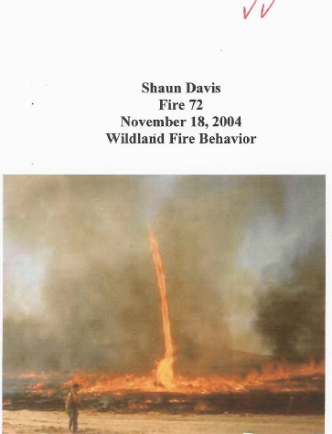
Example of title Page:
Title page Courtesy of Shaun Davis
Fall of 2004

Also, you are free to integrate graphic works throughout the body of your work as well. I have had many students do this type of work in their papers.

Remember there are many resources at your disposal to achieve your written assignments. If anyone in the class should have difficulty in composing a paper, the college has learning assistance centers to help you. Also, I am a resource you can consult along with many other instructors. Do not be afraid to seek assistance with your work! Bottom Line! Any questions, you only need to ask! Please Note! Your assignments are to be turned into the website under the assignment section!

Please refer to the following page on topics {choose one only) that can be used in your Term Paper. Also, if you have a topic you would like to cover that is not on the following list, you can ask me for possible approval.

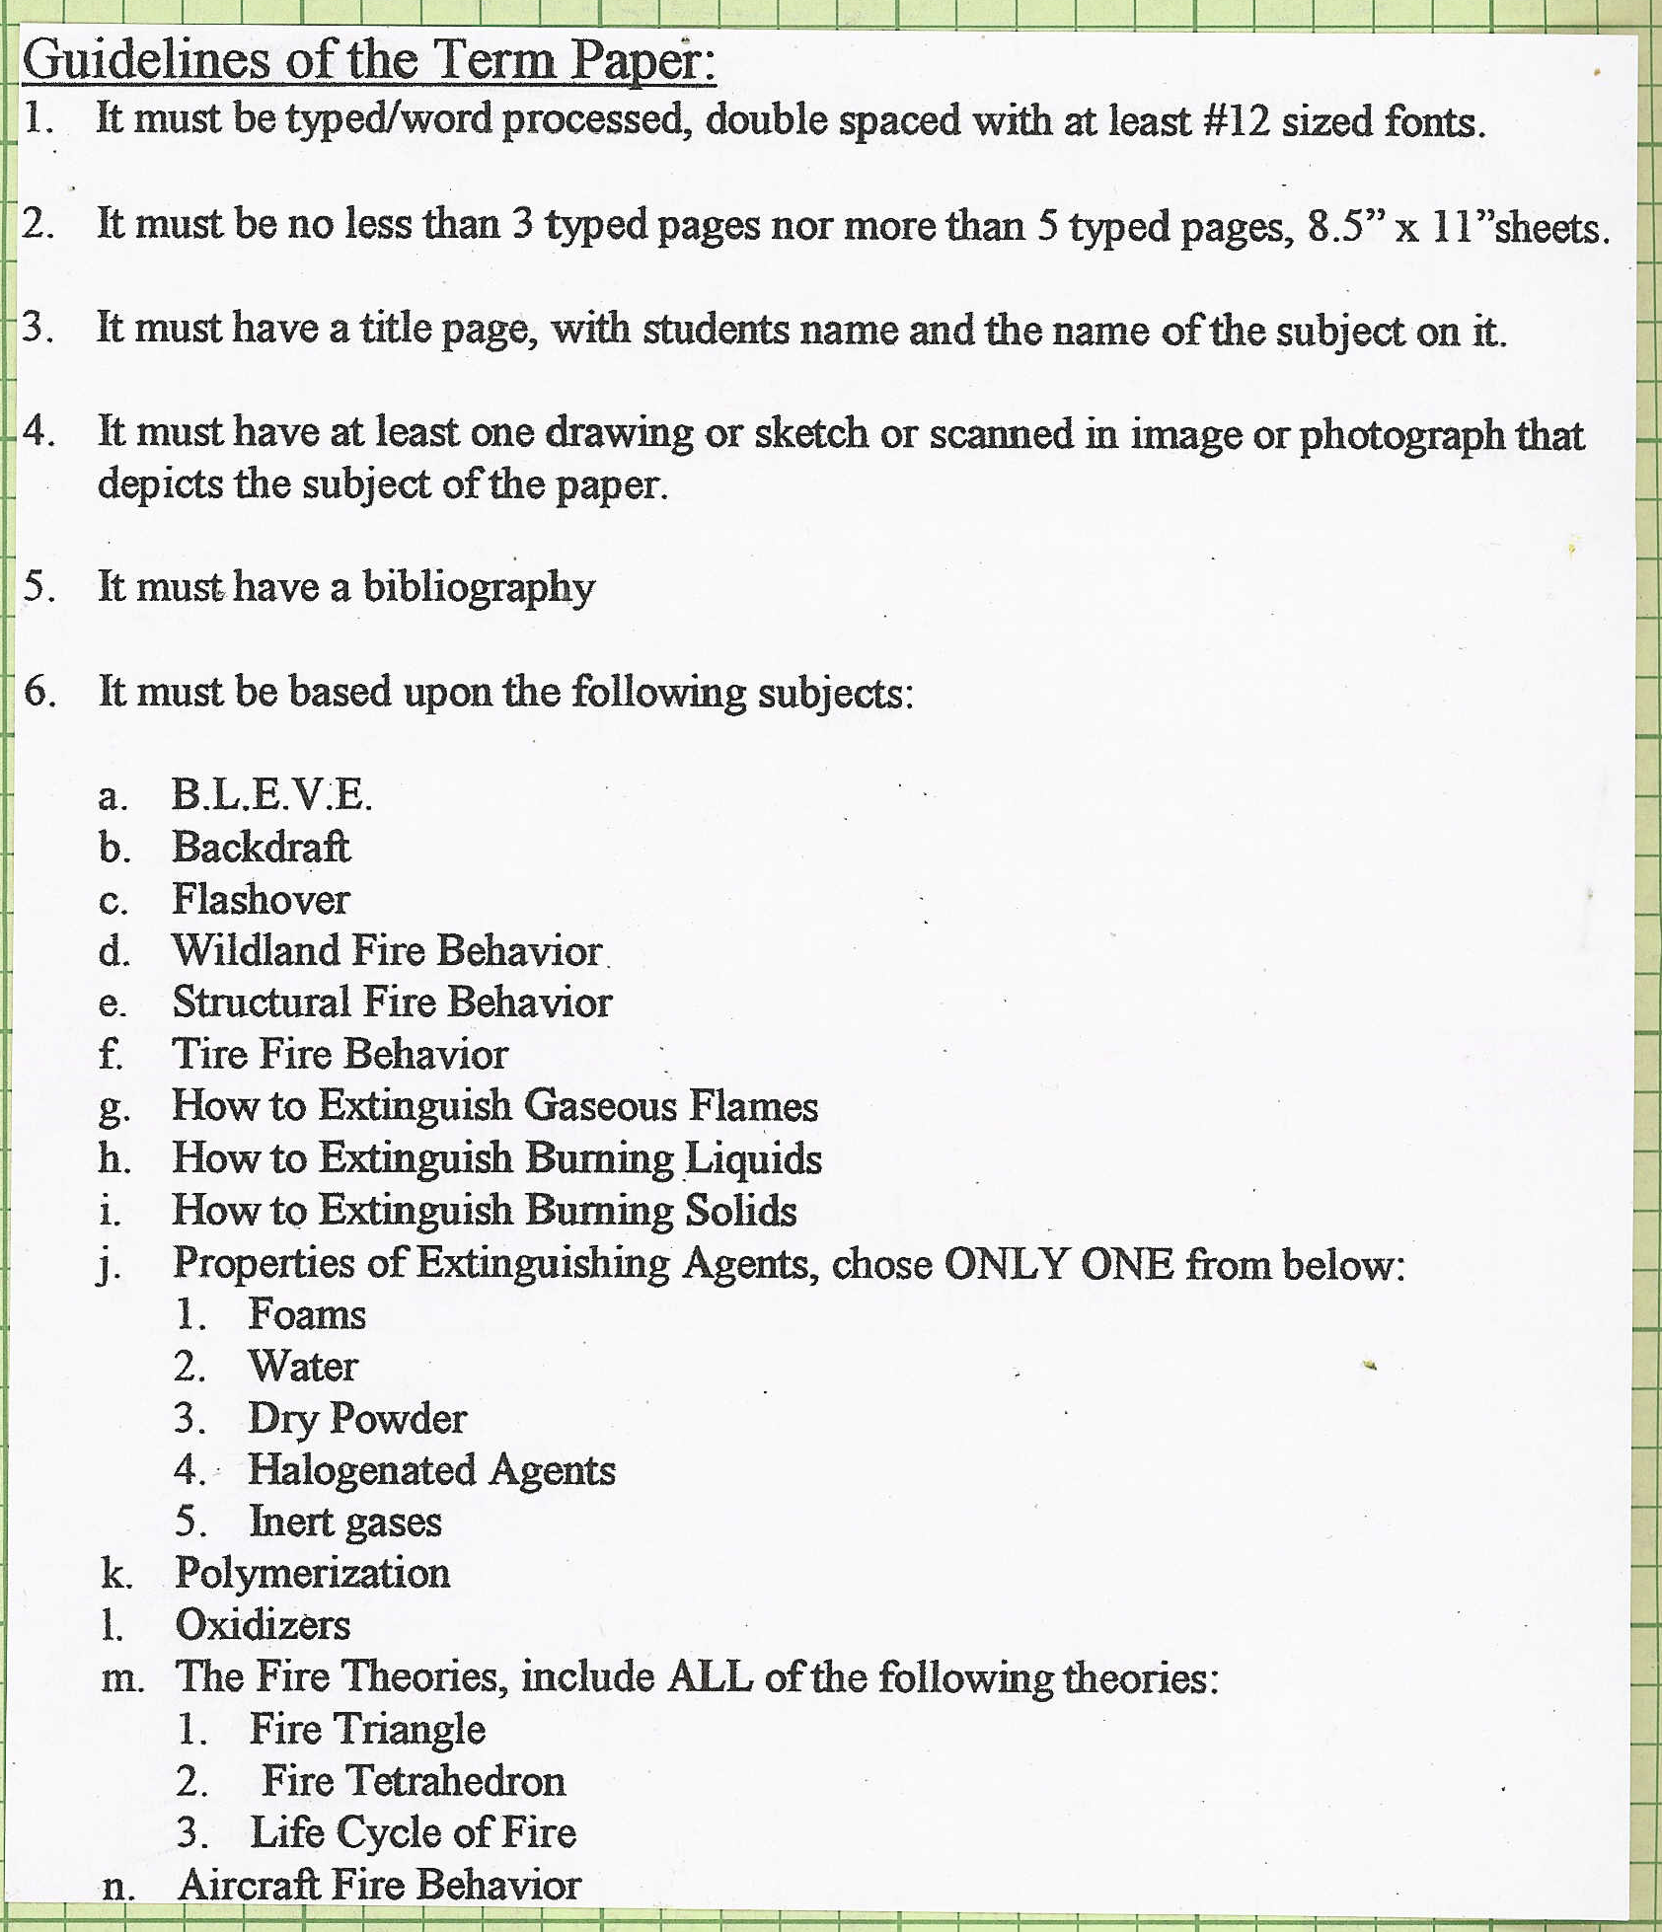
You can pick one topic from the list to do your term paper on. Also, you can submit a topic that may not be on the aforementioned list above for possible approval.

Note Page:__________________________________________________________________________________________________________________________________________________________________________________________________________________________________________________________________________________________________________________________________________________________________________________________________________________________________________________________________________________________________________________________________________________________________________________________________________________________________________________________________________________________________________________________________________________________________________________________________________________________________________________________________________________________________________________________________________________________________________________________________________________________________________________________________________________________________________________________________________________________________________________________________________________________________________________________________________________________________________________________________________________________________________________________________________________________________________________________________________________________________________________________________

